

Version

Publication date 29/07/2024

IMKL 2.3 to IMKL 3 Migration Guide

Author: Niels Gabriels

Athumi - Het Vlaams Datanutsbedrijf

Havenlaan 88, bus C

1000 Brussel

KBO 0795.547.478

info@athumi.eu



Creation date: 15/07/2024

Publication date: 29/07/2024

Internal file name: IMKL2.3 to IMKL3 migration guide.docx

Document history:

|  |  |  |  |  |
| --- | --- | --- | --- | --- |
| Version | Comments | Date | Author | Status |
| 1 | Document created | 15/07/2024 | Niels Gabriels |  |
|  |  |  |  |  |
|  |  |  |  |  |
|  |  |  |  |  |

# Table of Contents

Table of Contents 3

1 General changes 7

1.1 Introduction 7

1.2 IMKL namespace and dependencies 7

1.2.1 Schema imports 7

1.2.2 IMKL 3 namespace 8

1.2.3 Updated INSPIRE schemas 8

1.3 Language 9

1.3.1 Standardisation of language 9

1.3.2 Language-specific free text 9

1.4 Codelists 11

1.5 Order of elements 11

1.6 Geometry 12

1.6.1 Overview 12

1.6.2 Coordinate reference system 12

1.6.3 2.5D and srsDimension 12

1.7 Survey 13

2 Best Practices 15

2.1 Introduction 15

2.2 Precaution 15

2.3 Directional Drilling 17

2.4 Measurement Points and Drinking Water Extraction Points 18

3 UtilityNetwork 19

3.1 Overview 19

3.2 authorityRole (us-net-common) 20

3.3 disclaimer 20

3.4 utilityFacilityReference 20

3.5 authorityRole (IMKL) 21

3.6 documentation 21

3.6.1 ExtraPlan 21

3.6.2 Precautions 22

3.7 annotation 22

3.8 verticalPositionDetail 22

3.9 standardCoverageDetail 23

3.10 Topographical elements 23

4 DepthDetail and CoverageDetail 24

4.1 DepthDetail vs CoverageDetail 24

4.2 Overview 25

4.3 depth, height and verticalPosition 26

4.4 verticalPositionSurvey 26

4.5 referenceSurface 27

4.6 Associations 27

5 StandardCoverageDetail 29

6 ActivityComplex 30

6.1 Overview 30

6.2 geometrySurvey 30

6.3 Associations 31

7 TopographicalElement 32

7.1 Overview 32

7.2 locationSurvey 32

7.3 extraTopografieType 33

7.4 Associations 33

8 ProtectedArea 34

8.1 Overview 34

8.2 geometrySurvey 34

8.3 protectedAreaType 34

9 Document and ExtraPlan 35

9.1 Overview 35

9.2 bestandIdentificator 36

9.3 locationSurvey 36

9.4 Associations 37

10 Annotation 38

10.1 Overview 38

10.2 Associations 39

11 Appurtenance 40

11.1 Overview 40

11.2 geometrySurvey 40

11.3 elevatedRisk 41

11.4 visibility 41

11.5 appearance 42

11.6 depthDetail 43

11.7 documentation and annotation 43

12 Connection 44

13 UtilityNodeContainers: Tower, Pole, Manhole and Cabinet 47

14 Cables: ElectricityCable and TelecommunicationsCable 48

14.1 Overview 48

14.2 coverageDetail 49

14.3 pipeDiameterAccuracy 49

14.4 constructionTechnique 49

15 Pipes and Ducts 51

16 Entity-Relationship Diagrams 53

16.1 Overview 53

16.2 UtilityNetwork 54

16.3 ActivityComplex 55

16.4 Appurtenance 56

16.5 Connection 57

16.6 Tower 58

16.7 Pole 59

16.8 Manhole 60

16.9 Cabinet 61

16.10 ElectricityCable 62

16.11 TelecommunicationsCable 63

16.12 Pipe 64

16.13 OilGasChemicalsPipe 65

16.14 SewerPipe 66

16.15 WaterPipe 67

16.16 ThermalPipe 68

16.17 Duct 69

16.18 Document, ExtraPlan and Annotation 70

16.19 TopographicalElement 70

16.20 Types 71

# General changes

## Introduction

Several changes that have been made in IMKL 3 impact various entities. In this chapter these general changes are explained.

## IMKL namespace and dependencies

### Schema imports

To be able to use the IMKL 3 XSD and other required XSDs, they must be defined in the XML that is generated to represent the UtilityNetwork. This can be done as demonstrated in the example below. Schemas that are not used can be removed from the import.

Compared to IMKL 2.3 this means that in IMKL 3:

* the namespace URI for the *imkl* namespace needs to be updated (section 1.2.2);
* the namespace URIs for the *us-net-\** namespaces need to be checked. They should reference the correct 2023.1 version instead of the 2021.1 version (section 1.2.2).

Example IMKL 3:

|  |
| --- |
| <gml:FeatureCollection      xmlns:xsi="http://www.w3.org/2001/XMLSchema-instance"      xmlns:xlink="http://www.w3.org/1999/xlink"      xmlns:act-core="http://inspire.ec.europa.eu/schemas/act-core/4.0"      xmlns:us-net-common="http://inspire.ec.europa.eu/schemas/us-net-common/4.0"      xmlns:us-net-el="http://inspire.ec.europa.eu/schemas/us-net-el/4.0"      xmlns:us-net-tc="http://inspire.ec.europa.eu/schemas/us-net-tc/4.0"      xmlns:us-net-ogc="http://inspire.ec.europa.eu/schemas/us-net-ogc/4.0"      xmlns:us-net-sw="http://inspire.ec.europa.eu/schemas/us-net-sw/4.0"      xmlns:us-net-wa="http://inspire.ec.europa.eu/schemas/us-net-wa/4.0"      xmlns:us-net-th="http://inspire.ec.europa.eu/schemas/us-net-th/4.0"      xmlns:net="http://inspire.ec.europa.eu/schemas/net/4.0"      xmlns:base="http://inspire.ec.europa.eu/schemas/base/3.3"      xmlns:base2="http://inspire.ec.europa.eu/schemas/base2/2.0"      xmlns:imkl="http://TODO/imkl3"      xmlns:gml="http://www.opengis.net/gml/3.2"      xmlns:gmd="http://www.isotc211.org/2005/gmd"> |

### IMKL 3 namespace

With the update from IMKL 2.3 to IMKL 3, the namespace for IMKL has changed. This affects how entities and codelist values are referenced. The new namespace for IMKL 3 is yet to be defined. This document will be updated when the new namespace is known.

### Updated INSPIRE schemas

IMKL 3 uses the 2023.1 versions of the INSPIRE schemas, whereas IMKL 2.3 utilized the older 2021.1 versions.

In the namespace declarations, you should use the URIs as shown in the example above, referencing the latest 4.0 versions. If you have used the version-specific URIs from 2021.1 (e.g., <https://inspire.ec.europa.eu/schemas/2021.1/us-net-common/4.0/>), they need to be updated. If you used the general URIs (e.g., <https://inspire.ec.europa.eu/schemas/us-net-common/4.0/>), no update is necessary.

One significant update in the 2023.1 versions is the inclusion of an updated *ThermalNetwork.xsd* schema, which is now at version 4.0.1 (available at <https://inspire.ec.europa.eu/schemas/us-net-th/4.0>). The type of the *thermalProductType* element, which was undefined in version 4.0.0, has been added in version 4.0.1. However, the method for providing the *thermalProductType* remains unchanged from IMKL 2.3 (see the example below). The XSD was updated to provide a correct definition, as the *thermalProductType* was not clearly defined before.

Example of thermalProductType in IMKL 2.3 and IMKL 3:

|  |
| --- |
| <us-net-th:thermalProductType      xlink:href="https://inspire.ec.europa.eu/codelist/ThermalProductTypeExtendedValue/heatingSteam" /> |

The 2023.1 versions of the INSPIRE schemas do not include the *TelecommunicationsNetwork.xsd*. Instead, for IMKL 3, the draft XSD available at <http://inspire.ec.europa.eu/schemas/us-net-tc/4.0/TelecommunicationsNetwork.xsd> will be used. The draft schema is adopted to fill the gap left by the absence of an official release in the 2023.1 versions.

Aside from these changes, there are no other noteworthy differences in the 2023.1 schema versions.

## Language

### Standardisation of language

In IMKL 2.3, a mix of Dutch and English terminology was used. The English terms were derived from INSPIRE, while the Dutch terms were specific additions for IMKL. In IMKL 3, it has been decided to translate all Dutch terms (XML elements and codelist values) into English.

### Language-specific free text

In IMKL 3, various elements allow for the specification of free text, such as the disclaimer, labels, descriptions or the colour of cables or pipes. Since the usage of IMKL is no longer limited to Flanders, it is now necessary to indicate the language of the free text in these elements. The supported languages are German (#de), English (#en), French (#fr), or Dutch (#nl). For these language-specific free text fields it is also possible to provide text in multiple languages (see the example below).

Example of kleur IMKL 2.3:

|  |
| --- |
| <imkl:kleur>wit</imkl:kleur> |

Example of appearance and colour in IMKL 3:

|  |
| --- |
| <imkl:appearance>      <imkl:colour>          <gmd:PT_FreeText>              <gmd:textGroup>                  <gmd:LocalisedCharacterString locale="#en">  White  </gmd:LocalisedCharacterString>              </gmd:textGroup>              <gmd:textGroup>                  <gmd:LocalisedCharacterString locale="#nl">  Wit  </gmd:LocalisedCharacterString>              </gmd:textGroup>              <gmd:textGroup>                  <gmd:LocalisedCharacterString locale="#fr">  Blanc  </gmd:LocalisedCharacterString>              </gmd:textGroup>          </gmd:PT_FreeText>      </imkl:colour>  </imkl:appearance> |

In general, the *description* element in IMKL 3 replaces the *omschrijving* element from IMKL 2.3. Due to this change regarding language-specific free text, the *taal* (language) element that was present in most entities in IMKL 2.3 is no longer needed and has been removed in IMKL 3.

Example of omschrijving and taal in IMKL 2.3:

|  |
| --- |
| <imkl:omschrijving>Dit is een voorbeeld</imkl:omschrijving>  <imkl:taal xlink:href="Nederlands" /> |

Example of description in IMKL 3:

|  |
| --- |
| <imkl:description>      <gmd:PT_FreeText>          <gmd:textGroup>              <gmd:LocalisedCharacterString locale="#en">This is an example</gmd:LocalisedCharacterString>          </gmd:textGroup>          <gmd:textGroup>              <gmd:LocalisedCharacterString locale="#nl">Dit is een voorbeeld</gmd:LocalisedCharacterString>          </gmd:textGroup>          <gmd:textGroup>              <gmd:LocalisedCharacterString locale="#fr">Voici un exemple</gmd:LocalisedCharacterString>          </gmd:textGroup>      </gmd:PT_FreeText>  </imkl:description> |

This representation follows the existing method for displaying text in multiple languages, as defined in the INSPIRE XSDs.

Example of disclaimer in IMKL 2.3 and IMKL 3:

|  |
| --- |
| <us-net-common:disclaimer>      <gmd:PT_FreeText>          <gmd:textGroup>              <gmd:LocalisedCharacterString locale="#en">Example</gmd:LocalisedCharacterString>          </gmd:textGroup>          <gmd:textGroup>              <gmd:LocalisedCharacterString locale="#nl">Voorbeeld</gmd:LocalisedCharacterString>          </gmd:textGroup>          <gmd:textGroup>              <gmd:LocalisedCharacterString locale="#fr">Exemple</gmd:LocalisedCharacterString>          </gmd:textGroup>      </gmd:PT_FreeText>  </us-net-common:disclaimer> |

## Codelists

Several updates and additions have been made to codelists:

* New values are added to existing codelists
* The following new codelists are introduced:
  + SurveyMethodValue
  + VisibilityTypeValue
  + ReferenceSurfaceTypeValue
  + ConstructionTechniqueValue
* The following codelists have been removed:
  + TaalValue
  + ExtraTopografieTypeValue
  + NauwkeurigheidValue

To determine which codelist should be used for each element, please refer to the separate document: IMKL3_Codelists.xlsx. This document provides detailed information on the applicable codelists for each element in the IMKL 3 schema.

## Order of elements

The XSD schema of IMKL 3 defines which elements can appear per entity and specifies the order of these elements. In IMKL 3, the order of some elements has been changed compared to IMKL 2.3. This adjustment allows for the reuse of common elements through groups (e.g. imkl:UtilityNodeContainerGroup) which simplifies the XSD.

For the correct order of elements, please refer to the XSD schema itself or to the Entity-Relationship Diagrams associated with IMKL 3 (chapter 16). These resources provide detailed information on the sequence of elements required for each entity.

## Geometry

### Overview

In IMKL 3, the following changes have been made to geometries:

* The coordinate reference system has been updated from Lambert72 to Lambert2008.
* Z-coordinates are now allowed (2.5D), although their inclusion alongside XY-coordinates is optional.
* The srsDimension attribute is now mandatory.

These changes are further explained in Sections 1.6.2 and 1.6.3. If you do not plan to include Z-coordinates, you only need to:

* Reproject all geometries into Lambert2008.
* Add the srsDimension attribute and set its value to 2 (representing 2D coordinates).

### Coordinate reference system

In IMKL 2.3, Lambert72 (EPSG:31370) was used as the coordinate reference system. In IMKL 3, Lambert2008 (EPSG:3812) is used instead. This means that all coordinates need to be converted from Lambert72 to Lambert2008.

To specify the correct coordinate reference system, use the *srsName* attribute.

|  |
| --- |
| srsName="http://spatialreference.org/ref/epsg/3812/" |

### 2.5D and srsDimension

In IMKL 2.3, specifying z-coordinates was not allowed. IMKL 3 now supports the inclusion of 2.5D coordinates which means they can be provided when available for third-party use. However, the KLIP-viewer itself will not use z-coordinates. To provide depth information, it is recommended to include the *StandardCoverageDetail*, *DepthDetail* and *CoverageDetail* entities.

Note that only one Z-coordinate is required for every XY-coordinate pair. Therefore, in the context of IMKL 3 this is referred to as 2.5D rather than a true 3D representation of objects. The interpretation of the Z-coordinate should follow the same guidelines as those of the verticalPosition (chapter 4).

To differentiate between geometries specified in 2D and those in 2.5D, the *srsDimension* attribute must be added. For 2D coordinates, set srsDimension to 2. For 2.5D coordinates, set srsDimension to 3. Although the usage of 2.5D coordinates is optional, the srsDimension attribute itself is mandatory.

Figure 1 - 2D + depth (left) vs 2.5D (right)

Example of 2D coordinates:

|  |
| --- |
| <net:centrelineGeometry>    <gml:LineString srsName="http://spatialreference.org/ref/epsg/3812/" srsDimension="2">      <gml:posList>603516 692178 603576 692157</gml:posList>    </gml:LineString>  </net:centrelineGeometry> |

Example of 2.5D coordinates:

|  |
| --- |
| <net:centrelineGeometry>    <gml:LineString srsName="http://spatialreference.org/ref/epsg/3812/" srsDimension="3">      <gml:posList>603516 692178 20 603576 692157 20</gml:posList>    </gml:LineString>  </net:centrelineGeometry> |

Note that srsDimension with value 1 is also possible. This is the case when specifying a TAW/DNG level (Tweede Algemene Waterpassing / Deuxième Nivellement General). Here, EPSG:5710 is used. See section 4.3 for more information.

Example of a TAW/DNG level:

|  |
| --- |
| <imkl:verticalPosition srsName="http://spatialreference.org/ref/epsg/5710/"  srsDimension="1">22.02</imkl:verticalPosition> |

## Survey

In IMKL 3, a new element of type *Survey* has been introduced for entities where location, depth or vertical position information can be specified. This *Survey* element allows for the following data to be provided:

* **method:** Specifies the method used to determine the location, depth or vertical position. This element is mandatory but it can be empty and have a *nilReason*.
* **recordedBy:** Indicates the person or organization who conducted the survey. This element is optional.
* **date:** Specifies the date when the survey was conducted. This element is optional.
* **accuracy:** Provides the accuracy with which the location, depth or vertical position was determined. This element is mandatory but it can be empty and have a *nilReason*.

The *Survey* type is utilized in various places across IMKL 3. The name of the element varies depending on the entity it applies to, ensuring clarity in interpretation. For example:

* *ActivityComplex* includes a *geometry* and a *geometrySurvey*. The *geometrySurvey* applies to the *geometry*.
* *ExtraPlan* has a *location* and a *locationSurvey*. The *locationSurvey* applies to the *location*.
* *DepthDetail* includes a *verticalPosition*, *depth* or *height* and a *verticalPositionSurvey*. The *verticalPositionSurvey* applies to either the *verticalPosition*, *depth* or *height*.

A *Survey* element is available for entities with a geometry, excluding *Annotations*. It is mandatory for all cables, pipes, ducts, appurtenances, towers, poles, cabinets and manholes. For other entities it is optional.

# Best Practices

## Introduction

This section outlines several best practices for providing specific information in IMKL 3.These recommendations aim to enhance clarity and consistency in data representation.

## Precaution

In IMKL 2.3 the *voorzorgsmaatregel* element could be used to provide information on precautions. In IMKL 3 this element is removed and is replaced with a *documentation* reference. The entity that is referenced should be a *Document* entity. The *Document* entity is similar to an *ExtraPlan*, but without a location.

A *Document* entity representing a precaution must have its *documentType* set to *precaution*. The *precaution* value is added to the *DocumentTypeValue* codelist for this purpose and should not be used for *ExtraPlans*.

See chapters 3 and 9 for more information on the *UtilityNetwork* and *Document* entities.

Example IMKL 2.3:

|  |
| --- |
| <gml:featureMember>    <imkl:UtilityNetwork gml:id="ID_230dbcf3-4fbd-4118-9f57-b2f370f04107">      ...      <imkl:imklId>        <base:Identifier>          <base:localId>001</base:localId>          <base:namespace>aquacom-be</base:namespace>        </base:Identifier>      </imkl:imklId>      ...      <imkl:voorzorgsmaatregel>        <imkl:Voorzorgsmaatregel>          <imkl:bestandLocatie>voorzorgsmaatregel.pdf</imkl:bestandLocatie>          <imkl:bestandMediaType            xlink:href="http://mir.agiv.be/cl/IMKL/v2/BestandMediaTypeValue/PDF" />        </imkl:Voorzorgsmaatregel>      </imkl:voorzorgsmaatregel>      ...    </imkl:UtilityNetwork>  </gml:featureMember> |

Example IMKL 3:

|  |
| --- |
| <gml:featureMember>      <imkl:UtilityNetwork gml:id="ID_230dbcf3-4fbd-4118-9f57-b2f370f04107">          ...          <imkl:imklId>              <base:Identifier>                  <base:localId>001</base:localId>                  <base:namespace>aquacom-be</base:namespace>              </base:Identifier>          </imkl:imklId>          ...          <imkl:documentation xlink:href="http://TODO/Document/aquacom-be:D001" />      </imkl:UtilityNetwork>  </gml:featureMember>  <gml:featureMember>      <imkl:Document gml:id="ID_5b5e7f28-c98d-4bfd-bf0f-33e5c3cbb9c8">          <imkl:imklId>              <base:Identifier>                  <base:localId>D001</base:localId>                  <base:namespace>aquacom-be</base:namespace>              </base:Identifier>          </imkl:imklId>          <imkl:beginLifespanVersion>2001-12-17T09:30:47.0Z</imkl:beginLifespanVersion>          <imkl:documentType xlink:href="http://TODO/DocumentTypeValue/precaution" />          <imkl:documentLocation>extraplan1.png</imkl:documentLocation>          <imkl:documentMediaType xlink:href="http://TODO/DocumentMediaTypeValue/PNG" />          <imkl:inNetwork xlink:href="http://TODO/UtilityNetwork/aquacom-be:001" />      </imkl:Document>  </gml:featureMember> |

## Directional Drilling

In IMKL 2.3, there was no direct method to indicate that a cable, pipe or duct was installed using directional drilling (*gestuurde boring*). The only method available was to add an *ExtraPlan* with the *extraPlanType* set to *gestuurdeBoring*.

In IMKL 3, the *constructionTechnique* element can now be used to specify that a cable, pipe or duct is installed via a directional drilling by setting its value to *directionalDrilling*. It is strongly recommended to include the *constructionTechnique* element with the correct value when the construction technique is known. This allows elements with a specific construction technique to be visualized distinctly so they can be easily identified when looking at the map.

The *DocumentTypeValue* codelist in IMKL 3, which replaces the *ExtraPlanTypeValue* codelist from IMKL 2.3, still includes the option *directionalDrilling* (replacing *gestuurdeBoring)*. This allows for the addition of *ExtraPlans* providing additional documentation for a directional drilling.

An ExtraPlan with its *documentType* set to *directionalDrilling* must be linked to a cable, pipe or duct whose *constructionTechnique* is set to *directionalDrilling*. The validation will result in validation errors whenever this requirement is not met.

Example IMKL 3:

|  |
| --- |
| <gml:featureMember>      <imkl:Duct gml:id="ID_83dd154b-a708-4d93-bbe0-173f46e896da">          <net:beginLifespanVersion>2001-12-17T09:30:47.0Z</net:beginLifespanVersion>          <net:inspireId>              <base:Identifier>                  <base:localId>D001</base:localId>                  <base:namespace>telecom-be</base:namespace>              </base:Identifier>          </net:inspireId>         ...          <imkl:constructionTechnique              xlink:href="http://TODO/ConstructionTechniqueValue/directionalDrilling" />          ...      </imkl:Duct>  </gml:featureMember> |

## Measurement Points and Drinking Water Extraction Points

In some utility networks, measurement locations play an important role in measuring or monitoring specific values, such as groundwater levels. These measurement points are typically vertical drillings.

In IMKL 3, the recommended way to represent these utility network elements is by including them as *Appurtenance* entities. The following information can be provided for each measurement point:

* **Location:** The location should be provided as a 2D or 2.5D point.
* **Depth:** The depth of the *Appurtenance* can be provided by adding a *depthDetail* element. As explained in chapter 4 this depth should be interpreted as the lowest point of the *Appurtenance* (the total depth of the vertical drilling in this case).
* **Height:** An optional *height* element can be included to provide information on the total height of the *Appurtenance*, for example if some part extends above the surface.
* **Type:** The *appurtenanceType* element should be set to *measurementPoint*. This value is available in the following codelists: *OilGasChemicalsAppurtenanceTypeIMKLValue*, *SewerAppurtenanceTypeIMKLValue*, *WaterAppurtenanceTypeIMKLValue* and *ThermalAppurtenanceTypeIMKLValue*.

Extraction points for drinking water share similarities with measurement points, as both can be included as *Appurtenance* entities within IMKL 3. However, for these entities the *appurtenanceType* should be set to *drinkingWaterExtractionPoint*, which is available in the *WaterAppurtenanceTypeIMKLValue* codelist*.*

# UtilityNetwork

## Overview

The table below gives an overview of the elements within the *UtilityNetwork* entity that have changed in IMKL 3 compared to IMKL 2.3.

|  |  |  |
| --- | --- | --- |
| **IMKL 2.3** | **IMKL 3** | **Description** |
| omschrijving | description | Renamed |
| taal | / | Removed |
| technischContactpersoon | imkl:authorityRole | See the section on authorityRole (IMKL) |
| heeftDieptes | verticalPositionDetail | See the section on verticalPositionDetail |
| voorzorgsmaatregel | documentation | See the section on documentation |
| eigenUtilityFacilityReference | / | Removed  See the section on utilityFacilityReference |
| eigenExtraInformatie | / | Removed See the sections on documentation and annotation |
| heeftExtraTopografieen | / | Removed  See the section on Topographical elements |
| heeftBeschermdeGebieden | protectedArea | Renamed |
| standaardDekking | standardCoverageDetail | Renamed  See the section on standardCoverageDetail |
| heeftExtraInformatie | documentation or annotation | See the sections on documentation and annotation |

## authorityRole (us-net-common)

The element *us-net-common:authorityRole* must be present and must contain an empty *RelatedParty* element. This *authorityRole* element is ignored in IMKL 3, but it needs to be present to comply with the INSPIRE XSD.

This rule was already the case in IMKL 2.3, but it was not always used correctly.

Example IMKL 2.3 and IMKL 3:

|  |
| --- |
| <us-net-common:authorityRole>      <base2:RelatedParty />  </us-net-common:authorityRole> |

## disclaimer

It is strongly recommended to include a *disclaimer*. The *disclaimer* is an example of language-specific free text as explained above. This was already the case in IMKL 2.3.

Example IMKL 2.3 and IMKL 3:

|  |
| --- |
| <us-net-common:disclaimer>      <gmd:PT_FreeText>          <gmd:textGroup>              <gmd:LocalisedCharacterString locale="#en"> Example  </gmd:LocalisedCharacterString>          </gmd:textGroup>          <gmd:textGroup>              <gmd:LocalisedCharacterString locale="#nl">Voorbeeld  </gmd:LocalisedCharacterString>          </gmd:textGroup>      </gmd:PT_FreeText>  </us-net-common:disclaimer> |

## utilityFacilityReference

If an *ActivityComplex* is present it needs to be linked to from the *UtilityNetwork* entity. This can be done via the element *utilityFacilityReference*. This was already the case in IMKL 2.3.

In IMKL 2.3, when an *ActivityComplex* was only applicably to the *UtilityNetwork* itself and was not linked to any of the elements within the *UtilityNetwork*, this had to be indicated via the element *eigenUtilityFacilityReference*. This is no longer needed in IMKL 3: The absence of a relationship between an *ActivityComplex* and an element in the *UtilityNetwork* suffices to indicate that the *ActivityComplex* is applicable to the *UtilityNetwork* itself. Therefore, the element *eigenUtilityFacilityReference* is removed in IMKL 3.

## authorityRole (IMKL)

The element *imkl:authorityRole* must be present. It replaces the *technischContactpersoon* element of IMKL 2.3.

The *imkl:authorityRole* element is of type *AgentType*. The element should contain the contact information for the person or organisation acting as the point of contact for the utility network. It must include the following elements:

* **name:** The name of the person or organisation
* **phone:** The telephone number
* **email:** The email address

Example IMKL 2.3:

|  |
| --- |
| <imkl:technischContactpersoon>    <imkl:TechnischContactpersoon>      <imkl:naam>Athumi</imkl:naam>      <imkl:telefoon>0123456789</imkl:telefoon>      <imkl:email>example@athumi.eu</imkl:email>    </imkl:TechnischContactpersoon>  </imkl:technischContactpersoon> |

Example IMKL 3:

|  |
| --- |
| <imkl:authorityRole>      <imkl:name>Athumi</imkl:name>      <imkl:phone>0123456789</imkl:phone>      <imkl:email>example@athumi.eu</imkl:email>  </imkl:authorityRole> |

## documentation

### ExtraPlan

All *ExtraPlan*s that are relevant to the *UtilityNetwork* (i.e. applicable to the entire *UtilityNetwork* or to any of the elements within the network) should be linked to from the *UtilityNetwork* entity. This must be done via the *documentation* element. A *UtilityNetwork* can have as many *documentation* elements as needed.

In IMKL 2.3, when an *ExtraPlan* was applicable to the entire *UtilityNetwork* and was not specifically linked to any of the elements within the *UtilityNetwork*, this had to be indicated via the element *eigenExtraInformatie*. This is no longer needed in IMKL 3. The absence of a relationship between an *ExtraPlan* and an element in the *UtilityNetwork* suffices to indicate that the *ExtraPlan* is applicable to the UtilityNetwork itself and thus, to all elements within the network. Therefore, the element *eigenExtraInformatie* is removed in IMKL 3.

Example IMKL 3:

|  |
| --- |
| <imkl:documentation xlink:href="http://TODO/ExtraPlan/sewercom-be:EP001" /> |

### Precautions

In IMKL 2.3 the *voorzorgsmaatregel* element could be used to provide information on precautions. In IMKL 3 this element is removed and is replaced with a *documentation* reference. The entity that is referenced is similar to an *ExtraPlan*, but without a location. See chapter 9 for more information or the Precaution section in the chapter on best practices (chapter 2).

## annotation

All annotations that are relevant to the *UtilityNetwork* should be linked to from the *UtilityNetwork* entity. This must be done via the *annotation* element. A *UtilityNetwork* can have as many *annotation* elements as needed.

The same change regarding *eigenExtraInformatie* as described for *ExtraPlan* is applicable to *Annotations*. Although, it is recommended to link annotations to specific elements within the network whenever possible instead of linking them to the UtilityNetwork as a whole.

Example IMKL 3:

|  |
| --- |
| <imkl:annotation xlink:href="http://TODO/Annotation/sewercom-be:AN001" />  <imkl:annotation xlink:href="http://TODO/Annotation/sewercom-be:AN002" /> |

## verticalPositionDetail

The element *heeftDieptes* of IMKL 2.3 needs to be replaced with the *verticalPositionDetail* element in IMKL 3. All *CoverageDetail* and *DepthDetail* entities that are used for any element within the *UtilityNetwork* should be referenced here. A *UtilityNetwork* can have as many *verticalPosition* elements as needed. The entity or entities representing the standard coverage for the network should not be listed here.

Example IMKL 3:

|  |
| --- |
| <imkl:verticalPositionDetail xlink:href="http://TODO/DepthDetail/sewercom-be:CD001" />  <imkl:verticalPositionDetail xlink:href="http://TODO/DepthDetail/sewercom-be:DD002" />  <imkl:verticalPositionDetail xlink:href="http://TODO/DepthDetail/sewercom-be:DD003" /> |

## standardCoverageDetail

The element *standaardDekking* of IMKL 2.3 needs to be replaced with the *standardCoverageDetail* element in IMKL 3. In IMKL 2.3 a *UtilityNetwork* could only have a single standard coverage (standard dekking). In IMKL 3 however, it is possible for a *UtilityNetwork* to have multiple standard coverages allowing to specify different standard coverages depending on the theme.

A UtilityNetwork can have:

* at most 1 standard coverage per theme.
* at most 1 standard coverage without theme. If this is present, this will be used as the coverage for an element unless it is overruled by either a coverageDetail on the element itself or by a standardCoverageDetail with the same theme.

Example IMKL 3:

|  |
| --- |
| <imkl:standardCoverageDetail xlink:href="http://TODO/StandardCoverageDetail/sewercom-be:DD001" /> |

## Topographical elements

Topographical elements (known as *Extra Topografie* in IMKL 2.3) provide extra context of the area that can help with orientation on site: e.g. trees, fences or other landmarks. These elements are by definition not directly related to a *UtilityNetwork*. Because of this, the relationship between UtilityNetwork and TopographicalElement is removed in IMKL 3. Therefore, the element *heeftExtraTopografieen* of IMKL 2.3 is removed from the *UtilityNetwork* entity in IMKL 3.

# DepthDetail and CoverageDetail

## DepthDetail vs CoverageDetail

In IMKL 2.3 the *RelatieveDiepte* and *TAWDiepte* entities were used to provide information on the depth or vertical position of elements within a *UtilityNetwork*. In IMKL 3 these entities are replaced with the *DepthDetail* and *CoverageDetail* entities. Note that this is not a one for one replacement. Both *DepthDetail* and *CoverageDetail* can replace either of the *RelatieveDiepte* and *TAWDiepte* entities.

In IMKL 2.3 the *RelatieveDiepte* entity was used to represent a relative depth compared to the surface. *TAWDiepte* was used to represent an absolute TAW/DNG level (Tweede Algemene Waterpassing / Deuxième Nivellement Général).

In IMKl 3 the *DepthDetail* entity should be used for elements with a point geometry. It can be used to represent both a relative depth as well as a TAW/DNG level. **For entities with a point geometry the depth or vertical position information should be interpreted as the lowest point of the entity.**

Entities with a point geometry are:

* Appurtenance
* Connection
* Tower
* Pole
* Cabinet
* Manhole

The *CoverageDetail* entity should be used for elements with a line geometry. **For these elements the depth or vertical position information should be interpreted as the highest part of the element.**

Entities with a line geometry (via the referenced *UtilityLinks*) are:

* ElectricityCable
* TelecommunicationsCable
* Pipe
* OilGasChemicalsPipe
* SewerPipe
* WaterPipe
* ThermalPipe
* Duct

Since *DepthDetail* is applicable only for entities with a point geometry, it is not possible to provide a location together with the *DepthDetail*. On the other hand, it is required to provide a location in the *CoverageDetail* entity. Without a location it would not be clear to which location along the trajectory of the line the depth information applies. The *location* element replaces the *ligging* element of *RelatieveDiepte* and *TAWDiepte*.

## Overview

The table below gives an overview of the elements within the *DepthDetail and CoverageDetail* entities that have changed in IMKL 3 compared to the *RelatieveDiepte* and *TAWDiepte* of IMKL 2.3.

|  |  |  |
| --- | --- | --- |
| **IMKL 2.3** | **IMKL 3** | **Description** |
| diepteNauwkeurigheid | verticalPositionSurvey | See the section on verticalPositionSurvey |
| dieptePeil | depth, height or verticalPosition | See the section on depth, height and verticalPosition |
| datumOpmetingDieptePeil | verticalPositionSurvey | See the section on verticalPositionSurvey |
| ligging | location | Renamed |
| heeftKabelOfLeiding | on | Renamed  See the section on Associations |
| heeftLeidingElement | on | Renamed  See the section on Associations |
| heeftContainerLeidingElement | on | Renamed  See the section on Associations |
| heeftKabelEnLeidingContainer | on | Renamed  See the section on Associations |
| heeftUtilityNetwork | / | Removed  See the section on Associations |
| maaiveldPeil (TAWDiepte) | referenceSurface > verticalPosition | See the section on referenceSurface |
| datumOpmetingMaaiveldPeil (TAWDiepte) | referenceSurface > verticalPositionSurvey | See the section on referenceSurface |

## depth, height and verticalPosition

Every *DepthDetail* or *CoverageDetail* entity should have exactly one of the following elements:

* **depth:** The *depth* element replaces the *dieptePeil* element of the *RelatieveDiepte* entity. It represent the depth below the surface.
* **height:** The *height* element is similar to the *depth*, but it represents a height above the surface.
* **verticalPosition:** The *verticalPosition* element should be used to provide a TAW/DNG level. As such, a *DepthDetail* or *CoverageDetail* entity replaces the *TAWDiepte* entity of IMKL 2.3.  
  Note that the *srsName* and *srsDimension* attributes are required for this element.

Example of depth in IMKL 3:

|  |
| --- |
| <imkl:depth uom="urn:ogc:def:uom:OGC::cm">100</imkl:depth> |

Example of height in IMKL 3:

|  |
| --- |
| <imkl:height uom="urn:ogc:def:uom:OGC::cm">100</imkl:height> |

Example of verticalPosition in IMKL 3:

|  |
| --- |
| <imkl:verticalPosition  srsName="http://spatialreference.org/ref/epsg/5710/"       srsDimension="1">21.65  </imkl:verticalPosition> |

## verticalPositionSurvey

Every *DepthDetail* and *CoverageDetail* entity should have a *verticalPositionSurvey* element. This element is of type *Survey* and provides additional information on the depth, height or verticalPosition. It replaces the *diepteNauwkeurigheid* and *datumOpmetingDieptePeil* elements of *RelatieveDiepte* and *TAWDiepte*.

Example IMKL 3:

|  |
| --- |
| <imkl:verticalPositionSurvey>      <imkl:method nilReason="missing" xsi:nil="true" />      <imkl:date>2001-12-17T09:30:47Z</imkl:date>      <imkl:accuracy uom="urn:ogc:def:uom:OGC::cm">30</imkl:accuracy>  </imkl:verticalPositionSurvey> |

## referenceSurface

Every *DepthDetail* and *CoverageDetail* entity has an extra element (compared to *RelatieveDiepte* and *TAWDiepte* of IMKL 2.3) called *referenceSurface*. This element is mandatory and needs to have at least a *type* child element. This *type* element indicates the type of the reference surface. For now it should always be of type *surfaceLevel*.

Next to the *type* child element, the *referenceSurface* can have the following optional child elements:

* **verticalPosition:** The *verticalPosition* element can be used to indicate the TAW/DNG level of the reference surface at the given location. If no location is given for the reference surface, it is assumed that the location is the same as the location of the *UtilityNetwork* or *CoverageDetail* entity itself.  
  This element replaces the *maaiveldPeil* of the *TAWDiepte* entity of IMKL 2.3
* **verticalPositionSurvey:**The *verticalPositionSurvey* element is of type *Survey* and can be used to provide additional information on how the *verticalPosition* was determined. It can be used to provide for example the date the vertical position of the reference surface was determined and thus it replaces the *datumOpmetingMaaiveldPeil* element of the *TAWDiepte* entity of IMKL 2.3.
* **location**: The *location* element can be used if the location where the TAW/DNG level of the reference surface was determined is not the same as that of the *UtilityNetwork* or *CoverageDetail* entity it is linked to.
* **locationSurvey:** The *locationSurvey* element is of type *Survey* and can be used to provide additional information on how the location of the referenceSurface was determined.

Example IMKL 3:

|  |
| --- |
| <imkl:referenceSurface>      <imkl:type xlink:href="http://TODO/ReferenceSurfaceTypeValue/surfaceLevel" />      <imkl:verticalPosition srsName="http://spatialreference.org/ref/epsg/5710/"          srsDimension="1">22.02</imkl:verticalPosition>      <imkl:verticalPositionSurvey>          <imkl:method nilReason="unknown" xsi:nil="true" />          <imkl:date>2001-12-17T09:30:47Z</imkl:date>          <imkl:accuracy uom="urn:ogc:def:uom:OGC::cm" nilReason="unknown" xsi:nil="true"></imkl:accuracy>      </imkl:verticalPositionSurvey>  </imkl:referenceSurface> |

## Associations

In IMKL 2.3, the relationship between a *RelatieveDiepte* or *TAWDiepte* entity and its associated elements was established through one of the following elements: *heeftKabelOfLeiding*, *heeftLeidingElement*, *heeftContainerLeidingElement* or *heeftKabelEnLeidingContainer*. These elements have now been consolidated into a single element: *on*. The specific type of entity to which a *DepthDetail* or *CoverageDetail* entity is linked can be determined directly from the *href* attribute within the *on* element.

A single *DepthDetail* or *CoverageDetail* can also be linked to multiple elements in IMKL 3. If multiple elements have the same depth, height or vertical position information, the entity can be reused and needs to be provided only once. This was not possible in IMKL 2.3. This means a *DepthDetail* or *CoverageDetail* entity can have as many *on* elements as needed.

The element *heeftUtilityNetwork* is no longer needed in IMKL 3. The standard coverage of a UtilityNetwork is provided via a different entity: *StandardCoverageDetail*.

# StandardCoverageDetail

The *StandardCoverageDetail* entity can be used to provide one or more standard coverages for the *UtilityNetwork*. *StandardCoverageDetail* is similar to the *CoverageDetail* entity, but with the following differences:

* Because a standard coverage is not limited to specific elements there is no need to provide a specific location. Hence, there is no option to add the *location* or *locationSurvey* elements.
* Because a standard coverage is not linked to specific elements there is no *on* relationship. There is also no *heeftUtilityNetwork* element like there is in IMKL 2.3. The type of entity already implies that the entity is a standard coverage for the *UtilityNetwork*.
* There is an extra element called *subtheme*. If there are different standard coverages depending on the subtheme of cables, pipes or ducts, it is now possible to provide multiple standard coverages for a single UtilityNetwork. Via the *subtheme* element you can specify for which subtheme(s) the standard coverage should be used.  
  There should be at most one standard coverage per subtheme. There can also be at most one standard coverage without a subtheme per *UtilityNetwork*. The *StandardCoverageDetail* withoutsubtheme will be used as the standard coverage for all cables, pipes or ducts that do not have a standard coverage for their subtheme or that do not have an element specific coverage detail.

Example IMKL 3:

|  |
| --- |
| <imkl:StandardCoverageDetail gml:id="ID_be8fc9cc-775f-4469-a8ce-bf1c892e5e14">      <imkl:imklId>          <base:Identifier>              <base:localId>DD001</base:localId>              <base:namespace>sewercom-be</base:namespace>          </base:Identifier>      </imkl:imklId>      <imkl:beginLifespanVersion>2001-12-17T09:30:47Z</imkl:beginLifespanVersion>      <imkl:referenceSurface>          <imkl:type xlink:href="http://TODO/ReferenceSurfaceTypeValue/surfaceLevel" />      </imkl:referenceSurface>      <imkl:depth uom="urn:ogc:def:uom:OGC::cm">100</imkl:depth>      <imkl:verticalPositionSurvey>          <imkl:method nilReason="missing" xsi:nil="true" />          <imkl:date>2001-12-17T09:30:47Z</imkl:date>          <imkl:accuracy uom="urn:ogc:def:uom:OGC::cm">30</imkl:accuracy>      </imkl:verticalPositionSurvey>      <imkl:inNetwork          xlink:href="http://TODO/UtilityNetwork/sewercom-be:001" />  </imkl:StandardCoverageDetail> |

# ActivityComplex

## Overview

The table below gives an overview of the elements within the *ActivityComplex* entity that have changed in IMKL 3 compared to the *ActivityComplex* entity of IMKL 2.3.

|  |  |  |
| --- | --- | --- |
| **IMKL 2.3** | **IMKL 3** | **Description** |
| omschrijving | description | Renamed |
| taal | / | Removed |
| opKabelEnLeidingen | on | Replaced  See the section on Associations |
| opKabelEnLeidingContainers | on | Replaced  See the section on Associations |
| opContainerLeidingElementen | on | Replaced  See the section on Associations |
| opLeidingElementen | on | Replaced  See the section on Associations |
| heeftUtilityNetwork | / | Removed  See the section on Associations |
| / | geometrySurvey | Added  See the section on geometrySurvey |

## geometrySurvey

The *geometrySurvey* element is an optional element that is added to *ActivityComplex*. This element is of type *Survey* and provides information on the way the *ActivityComplex* geometry was determined. It did not exist in IMKL 2.3.

## Associations

In IMKL 2.3, the relationship between an *ActivityComplex* entity and its associated elements was established through any of the following elements: *opKabelEnLeidingen*, *opKabelEnLeidingContainers*, *opContainerLeidingElementen* and *opLeidingElementen*. These elements have now been consolidated into a single element: *on*. The specific type of entity to which a *ActivityComplex* entity is linked can be determined directly from the href attribute within the *on* element. An *ActivityComplex* can have as many on elements as required.

The element *heeftUtilityNetwork* is no longer needed. The absence of on elements already indicates that the *ActivityComplex* relates to the *UtilityNetwork* itself and not to specific elements.

Example IMKL 3:

|  |
| --- |
| <imkl:on xlink:href="http://TODO/SewerPipe/sewercom-be:001" />  <imkl:on xlink:href="http://TODO/SewerPipe/sewercom-be:002" />  <imkl:on xlink:href="http://TODO/Manhole/sewercom-be:M0001" />  <imkl:on xlink:href="http://TODO/Appurtenance/sewercom-be:004" />  <imkl:inNetwork xlink:href="http://TODO/UtilityNetwork/sewercom-be:001" /> |

# TopographicalElement

## Overview

Topographical elements provide extra context of the area that can help with orientation on site: e.g. trees, fences or other landmarks. In IMKL 2.3 this was known as *ExtraTopografie*. In IMKL 3 this is replaced with the *TopographicalElement* entity.

The table below gives an overview of the elements within the *TopographicalElement* entity that have changed in IMKL 3 compared to the *ExtraTopografie* entity of IMKL 2.3.

|  |  |  |
| --- | --- | --- |
| **IMKL 2.3** | **IMKL 3** | **Description** |
| omschrijving | description | Renamed |
| taal | / | Removed |
| ligging | location | Renamed |
| / | locationSurvey | Added  See the section on locationSurvey |
| extraTopografieType | / | Removed  See the section on extraTopografieType |
| inNetwork | / | Removed  See the section on Associations |

## locationSurvey

The *locationSurvey* element is an optional element that is added to *TopographicalElement*. This element is of type *Survey* and provides information on the way the *TopographicalElement* geometry was determined. It did not exist in IMKL 2.3. The information about the *locationSurvey* is not currently visible in the KLIP viewer. Therefore, providing it is optional, although it can be useful for advanced use cases, such as impact analysis based on IMKL data.

## extraTopografieType

The *extraTopografieType* element of *ExtraTopografie* in IMKL 2.3 was rarely used. Therefore, it was decided to remove this element in IMKL 3.

## Associations

*TopographicalElements* are by definition not related to a *UtilityNetwork*. Because of this the relationship between *UtilityNetwork* and *TopographicalElement* is removed in IMKL 3. Therefore, the element *inNetwork* no longer exists in the *TopographicalElement* entity.

# ProtectedArea

## Overview

The *ProtectedArea* entity replaces the *BeschermdGebied* entity of IMKL 2.3.

The table below gives an overview of the elements within the *ProtectedArea* entity that have changed in IMKL 3 compared to the *BeschermdGebied* entity of IMKL 2.3.

|  |  |  |
| --- | --- | --- |
| **IMKL 2.3** | **IMKL 3** | **Description** |
| label | name | Renamed |
| omschrijving | description | Renamed |
| taal | / | Removed |
| beschermdGebiedType | protectedAreaType | Renamed |
| ligging | geometry | Renamed |
| / | geometrySurvey | Added  See the section on geometrySurvey |

## geometrySurvey

The *geometrySurvey* element is an optional element that is added to *ProtectedArea*. This element is of type *Survey* and provides information on the way the *ProtectedArea* geometry was determined. It did not exist in IMKL 2.3. The information about the *geometrySurvey* is not currently visible in the KLIP viewer. Therefore, providing it is optional.

## protectedAreaType

The protectdAreaType element is used to specify the type of the protected area. For IMKL 3, the existing codelist is expanded with the following types:

* **infiltrationArea:** This type of protected area can be used for areas that are used for water infiltration.

# Document and ExtraPlan

## Overview

The *Document* entity in IMKL 3 replaces the *voorzorgsmaatregel* element that was part of a UtilityNetwork in IMKL 2.3. Instead of an embedded element within the *UtilityNetwork* the *Document* is a separate entity that is referenced from the *UtilityNetwork* via the *documentation* element. *Documents* representing a precaution (replacing the *voorzorgsmaatregel)* should have a *documentType* of *precaution*.

*ExtraPlan* entities in IMKL 3 are similar to the *ExtraPlan* entities of IMKL 2.3 In IMKL 3, *ExtraPlans* are an extension of the *Document* entity type. *ExtraPlans* have a mandatory *location* and an optional *locationSurvey* element whereas *Documents* have neither of these elements. *ExtraPlans* can also have optional *refersTo* elements allowing to link ExtraPlans with UtilityNetwork elements.

The table below gives an overview of the elements within the *Document* and *ExtraPlan* entities that have changed in IMKL 3 compared to the *ExtraPlan* entity of IMKL 2.3.

|  |  |  |
| --- | --- | --- |
| **IMKL 2.3** | **IMKL 3** | **Description** |
| omschrijving | description | Renamed |
| taal | / | Removed |
| extraPlanType | documentType | Renamed  Added for precautions (voorzorgsmaatregel) |
| bestandLocatie | documentLocation | Renamed |
| bestandMediaType | documentMediaType | Renamed |
| ligging | location | Renamed **Only applicable for ExtraPlan** |
| / | locationSurvey | Added  See the section on locationSurvey **Only applicable for ExtraPlan** |
| bestandIdentificator | / | Removed  See the section on bestandIdentificator |
| opKabelEnLeidingen | refersTo | Renamed **Only applicable for ExtraPlan**  See the section on Associations |
| opLeidingElementen | refersTo | Renamed  **Only applicable for ExtraPlan**  See the section on Associations |
| opKabelEnLeidingContainers | refersTo | Renamed  **Only applicable for ExtraPlan**  See the section on Associations |
| opContainerLeidingElementen | refersTo | Renamed  **Only applicable for ExtraPlan**  See the section on Associations |
| inNetwork | inNetwork | Added for precautions (voorzorgsmaatregel)  See the section on Associations |
| heeftUtilityNetwork | / | Removed  See the section on Associations |

## bestandIdentificator

The *bestandIdentificator* element of *ExtraPlan* in IMKL 2.3 was rarely used. Therefore, it was decided to remove this element in IMKL 3.

## locationSurvey

The *locationSurvey* element is an optional element that is added to *ExtraPlan*. This element is of type *Survey* and provides information on the way the *ExtraPlan* location was determined. It did not exist in IMKL 2.3. The information about the *locationSurvey* is not currently visible in the KLIP viewer. Therefore, providing it is optional.

## Associations

In IMKL 2.3, the relationship between an *ExtraPlan* entity and its associated elements was established through any of the following elements: *opKabelEnLeidingen*, *opKabelEnLeidingContainers*, *opContainerLeidingElementen* and *opLeidingElementen*. These elements have now been consolidated into a single element: *refersTo*. The specific type of entity to which an *ExtraPlan* entity is linked can be determined directly from the href attribute within the *refersTo* element. An *ExtraPlan* can have as many *refersTo* elements as required. *Documents* do not have the *refersTo* element. A *Document* can only be linked to a *UtilityNetwork* and thus does not need the *refersTo* element.

The element *heeftUtilityNetwork* is no longer needed. The absence of *refersTo* elements already indicates that the *Document* or *ExtraPlan* relates to the *UtilityNetwork* itself and not to specific elements.

Because *voorzorgsmaatregel* is no longer embedded within *UtilityNetwork*, but rather a separate *Document* entity it also requires the *inNetwork* association similar to the *inNetwork* association that was already present for *ExtraPlan*.

# Annotation

## Overview

The *Annotation* entity in IMKL 3 replaces the *Annotatie* entity from IMKL 2.3.

The table below provides an overview of the elements within the *Annotation* entity that have changed in IMKL 3 compared to the *Annotatie* entity in IMKL 2.3.

|  |  |  |
| --- | --- | --- |
| **IMKL 2.3** | **IMKL 3** | **Description** |
| label | text | Renamed |
| omschrijving | description | Renamed |
| taal | / | Removed |
| opKabelEnLeidingen | associatedWith | Renamed  See the section on Associations |
| opLeidingElementen | associatedWith | Renamed  See the section on Associations |
| opKabelEnLeidingContainers | associatedWith | Renamed  See the section on Associations |
| opContainerLeidingElementen | associatedWith | Renamed  See the section on Associations |
| heeftUtilityNetwork | / | Removed  See the section on Associations |
| annotatieType | annotationType | Renamed |
| rotatiehoek | rotationAngle | Renamed |
| ligging | location | Renamed |

## Associations

In IMKL 2.3, the relationship between an *Annotatie* entity and its associated elements was established through any of the following elements: *opKabelEnLeidingen*, *opKabelEnLeidingContainers*, *opContainerLeidingElementen*, or *opLeidingElementen*. These elements have now been consolidated into a single element: *associatedWith*. The specific type of entity to which an *Annotation* is linked can be determined directly from the href attribute within the *associatedWith* element. An *Annotation* can include as many *associatedWith* elements as needed.

Additionally, the *heeftUtilityNetwork* element is no longer required. If no *associatedWith* elements are present, it is implicitly understood that the *Annotation* applies to the *UtilityNetwork* as a whole, rather than to individual elements within it.

# Appurtenance

## Overview

The table below provides an overview of the elements within the *Appurtenance* entity that have changed in IMKL 3 compared to the *Appurtenance* entity in IMKL 2.3.

|  |  |  |
| --- | --- | --- |
| **IMKL 2.3** | **IMKL 3** | **Description** |
| omschrijving | text | Renamed |
| taal | / | Removed |
| liggingNauwkeurigheid | geometrySurvey | See the section on geometrySurvey |
| orientatie | orientation | Renamed |
| subThema | subtheme | Renamed |
| isRisicovol | / | Removed See the section on elevatedRisk |
| / | elevatedRisk | See the section on elevatedRisk |
| isBovengrondsZichtbaar | visibility | See the section on visibility |
| kleur | appearance | See the section on appearance |
| diepte | depthDetail | See the section on depthDetail |
| heeftExtraInformatie | documentation or annotation | See the section on documentation and annotation |
| hoogte | height | Renamed |

## geometrySurvey

The *geometrySurvey* element is an mandatory element that is added to *Appurtenance*. This element is of type *Survey* and provides information on how the *Appurtenance* geometry was determined. The *geometrySurvey* element replaces the *liggingNauwkeurigheid* element of IMKL 2.3.

## elevatedRisk

In IMKL 2.3, the *isRisicoVol* element was used to indicate whether a utility network element could be considered risky. However, due to the difficulty in clearly defining what constitutes "risky," this element has been removed in IMKL 3.

In its place, IMKL 3 introduces a new optional element called *elevatedRisk*, which can be applied to all utility network elements. When its value is set to *true*, this element is used to signify that the risk associated with a particular utility network element is **higher than the standard risk level for the corresponding utility network**. It does not comment on the absolute risk level but instead provides a relative comparison to other elements within the same utility network.

Based on the above definition, elements with an elevated risk should be the exception rather than the rule. This distinction is why the *elevatedRisk* element is considered here as a new element rather than simply a renaming of the *isRisicoVol* element.

The primary purpose of the *elevatedRisk* element is to alert people working on-site that **extra safety precautions might be necessary** beyond the usual safety measures for typical utility network elements managed by a particular network operator. These additional safety measures can be documented as part of the overall precautions linked to the *UtilityNetwork* (as a *Document*) or as *ExtraPlans* linked to the element itself.

The *elevatedRisk* element is optional. If the element is not provided, it is interpreted as indicating that the element does not have an elevated risk, equivalent to including the element with a *false* value.

The information on *elevatedRisk* can be utilized in the KLIP viewer to highlight elements that possess an elevated risk and to alert users to review the related documents. The specific implementation of this functionality in the KLIP viewer is yet to be determined and is beyond the scope of this document.

## visibility

In IMKL 2.3, the *isBovengrondsZichtbaar* element, which was of type Boolean, has been replaced by the *visibility* element in IMKL 3. The *visibility* element is now a codelist rather than a Boolean type.

The mapping of values is as follows:

* A *true* value for *isBovengrondsZichtbaar* should be replaced with *visibleAboveGround*.
* A *false* value for *isBovengrondsZichtbaar* should be replaced with *notVisibleAboveGround*.

This change allows for a more detailed categorization in the future.

Example IMKL 2.3:

|  |
| --- |
| <imkl:isBovengrondsZichtbaar>false</imkl:isBovengrondsZichtbaar> |

Example IMKL 3:

|  |
| --- |
| <imkl:visibility xlink:href="http://TODO/VisibilityTypeValue/notVisibleAboveGround" /> |

## appearance

In IMKL 2.3, the *kleur* element has been replaced by the *appearance* element. While the *kleur* element was a simple text field, the *appearance* element is now a complex type. Currently, the *appearance* element contains a single child element: *colour*. The *colour* element is a language-specific string, allowing the specification of the colour in any of the supported languages.

Example IMKL 2.3:

|  |
| --- |
| <imkl:kleur>wit</imkl:kleur> |

Example IMKL 3:

|  |
| --- |
| <imkl:appearance>      <imkl:colour>          <gmd:PT_FreeText>              <gmd:textGroup>                  <gmd:LocalisedCharacterString locale="#en">  White  </gmd:LocalisedCharacterString>              </gmd:textGroup>              <gmd:textGroup>                  <gmd:LocalisedCharacterString locale="#nl">  Wit  </gmd:LocalisedCharacterString>              </gmd:textGroup>              <gmd:textGroup>                  <gmd:LocalisedCharacterString locale="#fr">  Blanc  </gmd:LocalisedCharacterString>              </gmd:textGroup>          </gmd:PT_FreeText>      </imkl:colour>  </imkl:appearance> |

## depthDetail

The *depthDetail* element replaces the *diepte* element from IMKL 2.3. Instead of referencing a *RelatieveDiepte* or *TAWDiepte* entity, the *depthDetail* element should reference a *DepthDetail* entity.

For more information, refer to the DepthDetail and CoverageDetail section of the documentation.

## documentation and annotation

The *documentation* and *annotation* elements replace the *heeftExtraInformatie* element from IMKL 2.3. Previously, the *heeftExtraInformatie* element could reference both *ExtraPlan* and *Annotatie* entities. This element is now divided into two distinct elements:

* The *documentation* element should reference *ExtraPlan* entities.
* The *annotation* element should reference *Annotation* entities.

An *Appurtenance* can have as many *documentation* and *annotation* elements as needed.

# Connection

In IMKL 2.3, some *Appurtenances* could have an *aansluiting* linked to them via the *ExtraInformatie* element. This allowed to provide address information for the *Appurtenance*. The *aansluiting* could only be linked to *Appurtenances* with a specific *appurtenanceType*.

In IMKL 3, the *aansluiting* entity has been removed and is replaced with the *Connection* entity. The *Connection* entity is a specific type of *Appurtenance* and includes one additional (optional) element called *address*. A *Connection* must still have one of the specific *appurtenanceTypes*:

* WaterAppurtenanceTypeIMKLValue – deliveryPoint
* ThermalAppurtenanceTypeIMKLValue – deliveryPoint
* ElectricityAppurtenanceTypeExtendedValue – deliveryPoint
* OilGasChemicalsAppurtenanceTypeExtendedValue – deliveryPoint
* TelecommunicationsAppurtenanceTypeExtendedValue – termination
* SewerAppurtenanceTypeIMKLValue - deliveryPoint

The *address* element includes the following child elements:

* **municipalityName:** The *municipalityName* element is mandatory and replaces the *gemeente* element of IMKL 2.3*.* The *municipality* is a language-specific string.
* **streetName:** The *streetName* element is mandatory and replaces the *straatnaam* element of IMKL 2.3*.* The *streetName* is a language-specific string.
* **houseNumber:** The *houseNumber* element is optional and replaces the *huisnummer* element of IMKL 2.3*.* The *houseNumber* is a simple string.
* **postalCode:** The *postalCode* element is optional and replaces the *postcode* element of IMKL 2.3*.* The *postalCode* is a simple string.

Example IMKL 2.3:

|  |
| --- |
| <gml:featureMember>      <imkl:Aansluiting gml:id="ID_1">          <imkl:imklId>              <base:Identifier>                  <base:localId>AS001</base:localId>                  <base:namespace>gascom-be</base:namespace>              </base:Identifier>          </imkl:imklId>          <imkl:beginLifespanVersion>2001-12-17T09:30:47.0Z</imkl:beginLifespanVersion>          <imkl:inNetwork xlink:href="http://mir.agiv.be/data/IMKL/v2.3/UtilityNetwork/gascom-be:001" />          <imkl:opLeidingElementen              xlink:href="http://mir.agiv.be/data/IMKL/v2.3/Appurtenance/gascom-be:002" />          <imkl:adres>              <imkl:Adres>                  <imkl:gemeente>Gent</imkl:gemeente>                  <imkl:straatnaam>Koningin Fabiolalaan</imkl:straatnaam>                  <imkl:huisnummer>5</imkl:huisnummer>                  <imkl:postcode>9000</imkl:postcode>              </imkl:Adres>          </imkl:adres>      </imkl:Aansluiting>  </gml:featureMember> |

Example IMKL 3:

|  |
| --- |
| <imkl:address>      <imkl:municiaplityName>          <gmd:PT_FreeText>              <gmd:textGroup>                  <gmd:LocalisedCharacterString locale="#fr">Gand</gmd:LocalisedCharacterString>              </gmd:textGroup>              <gmd:textGroup>                  <gmd:LocalisedCharacterString locale="#nl">Gent</gmd:LocalisedCharacterString>              </gmd:textGroup>          </gmd:PT_FreeText>      </imkl:municiaplityName>      <imkl:streetName>          <gmd:PT_FreeText>              <gmd:textGroup>                  <gmd:LocalisedCharacterString locale="#nl">Koningin Fabiolalaan</gmd:LocalisedCharacterString>              </gmd:textGroup>          </gmd:PT_FreeText>      </imkl:streetName>      <imkl:houseNumber>5</imkl:houseNumber>      <imkl:postalCode>9000</imkl:postalCode>  </imkl:address> |

# UtilityNodeContainers: Tower, Pole, Manhole and Cabinet

The table below provides an overview of the elements within the *UtilityNodeContainer* entities that have changed in IMKL 3 compared to their corresponding entities in IMKL 2.3. The UtilityNodeContainers entities are: *Tower*, *Pole*, *Manhole* and *Cabinet*.

|  |  |  |
| --- | --- | --- |
| **IMKL 2.3** | **IMKL 3** | **Description** |
| / | beginLifespanVersion | Added to be in line with all other elements |
| / | endLifespanVersion | Added to be in line with all other elements |
| omschrijving | description | Renamed |
| taal | / | Removed |
| liggingNauwkeurigheid | geometrySurvey | See the geometrySurvey section in the Appurtenance chapter. |
| orientatie | orientation | Renamed |
| isRisicovol | / | Removed See the elevatedRisk section in the Appurtenance chapter. |
| / | elevatedRisk | See the elevatedRisk section in the Appurtenance chapter. |
| isBovengrondsZichtbaar | visibility | See the visibility section in the Appurtenance chapter. |
| kleur | appearance | See the appearance section in the Appurtenance chapter. |
| diepte | depthDetail | See the depthDetail section in the Appurtenance chapter. |
| heeftExtraInformatie | documentation or annotation | See the documentation and annotation section in the Appurtenance chapter. |

# Cables: ElectricityCable and TelecommunicationsCable

## Overview

The table below provides an overview of the elements within the *ElectricityCable and TelecommunicationsCable* entities that have changed in IMKL 3 compared to their corresponding entities in IMKL 2.3.

|  |  |  |
| --- | --- | --- |
| **IMKL 2.3** | **IMKL 3** | **Description** |
| omschrijving | description | Renamed |
| taal | / | Removed |
| liggingNauwkeurigheid | geometrySurvey | See the geometrySurvey section in the Appurtenance chapter |
| isRisicovol | / | Removed See the elevatedRisk section in the Appurtenance chapter. |
| / | elevatedRisk | See the elevatedRisk section in the Appurtenance chapter. |
| isBovengrondsZichtbaar | visibility | See the visibility section in the Appurtenance chapter. |
| kleur | appearance | See the appearance section in the Appurtenance chapter |
| materiaalType | materialType | Renamed |
| technischeSpecificaties | technicalSpecifications | Renamed |
| dekking | coverageDetail | See the coverageDetail section |
| heeftExtraInformatie | documentation or annotation | See the documentation and annotation section in the Appurtenance chapter |
| / | constructionTechnique | See the constructionTechnique section |
| / | pipeDiameterAccuracy | Added  See the pipeDiameterAccuracy section |

## coverageDetail

The *coverageDetail* element replaces the *dekking* element from IMKL 2.3. Instead of referencing a *RelatieveDiepte* or *TAWDiepte* entity, the *coverageDetail* element should reference a *CoverageDetail* entity.

For more information, refer to the DepthDetail and CoverageDetail section of the documentation.

Example IMKL 3:

|  |
| --- |
| <imkl:coverageDetail xlink:href="http://TODO/DepthDetail/sewercom-be:CD001" /> |

## pipeDiameterAccuracy

The *pipeDiameterAccuracy* element has been added to provide additional information on the accuracy of the *pipeDiameter*. This element is of type *MeasureType* and accepts the following units: mm, cm and m. The *pipeDiameterAccuracy* element is optional.

Example IMKL 3:

|  |
| --- |
| <imkl:pipeDiameterAccuracy uom="urn:ogc:def:uom:cm">10</imkl:pipeDiameterAccuracy> |

## constructionTechnique

The *constructionTechnique* element has been added in IMKL 3. This element allows providing additional information regarding the construction technique used during the construction or installation of a cable, pipe or duct. This element is optional, but it is recommended to include it if information about the construction technique is available. If no information is available this can be clarified by adding the element with a *nilReason*.

The *constructionTechnique* should be a valid value from the *ConstructionTechniqueCodelist*. The allowed values are:

* openTrench
* directionalDrilling
* culvert
* other

# Pipes and Ducts

The table below provides an overview of the elements within the *Pipe* and *Duct* entities that have changed in IMKL 3 compared to their corresponding entities in IMKL 2.3. The Pipe entities are: *Pipe*, *OilGasChemicalsPipe*, *SewerPipe*, *WaterPipe* and *ThermalPipe*

|  |  |  |
| --- | --- | --- |
| **IMKL 2.3** | **IMKL 3** | **Description** |
| omschrijving | description | Renamed |
| taal | / | Removed |
| liggingNauwkeurigheid | geometrySurvey | See the geometrySurvey section in the Appurtenance chapter. |
| isRisicovol | / | Removed See the elevatedRisk section in the Appurtenance chapter. |
| / | elevatedRisk | See the elevatedRisk section in the Appurtenance chapter. |
| isBovengrondsZichtbaar | visibility | See the visibility section in the Appurtenance chapter. |
| kleur | appearance | See the appearance section in the Appurtenance chapter |
| materiaalType | materialType | Renamed |
| technischeSpecificaties | technicalSpecifications | Renamed |
| dekking | coverageDetail | See the coverageDetail section in the Cables chapter. |
| heeftExtraInformatie | documentation or annotation | See the documentation and annotation section in the Appurtenance chapter |
| / | pipeDiameterAccuracy | See the pipeDiameterAccuracy section in the Cables chapter. **Only applicable for Pipes.** |
| / | ductWidthAccuracy | Similar to pipeDiameterAccuracy. **Only applicable for Ducts.** |
| / | constructionTechnique | See the constructionTechnique section in the Cables chapter |
| subThema | subtheme | Renamed |
| temperatuur | temperature | Renamed. **Only applicable for ThermalPipe** |

# Entity-Relationship Diagrams

## Overview

This chapter presents the Entity-Relationship Diagrams (ERDs) for the IMKL 3 specification. To enhance readability, the diagrams are divided into multiple diagrams, each concentrating on a specific entity. Each diagram includes only the entities and relationships relevant to the entity in focus. The order of the attributes in the diagrams represents the sequence in which the elements should appear in the XML.

## UtilityNetwork

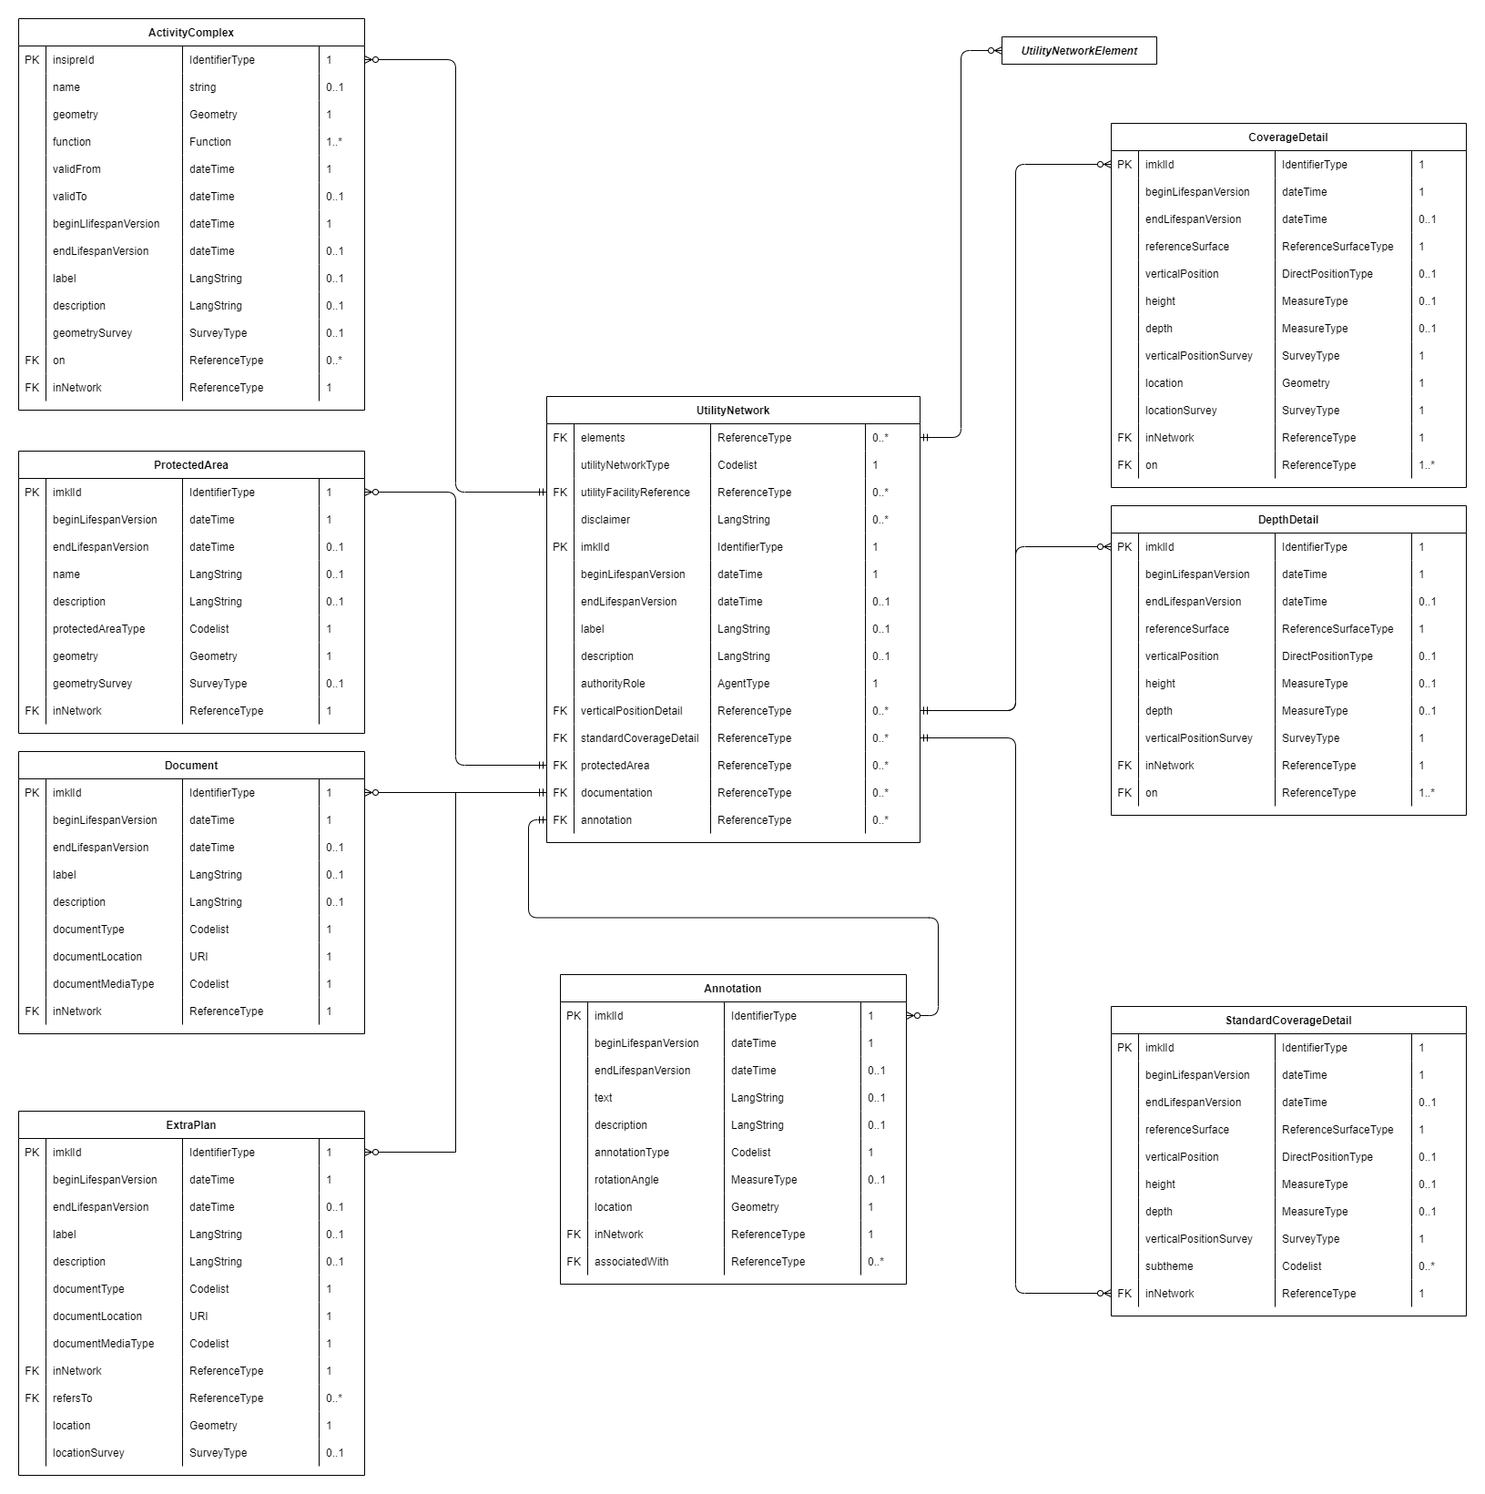

## ActivityComplex

## Appurtenance

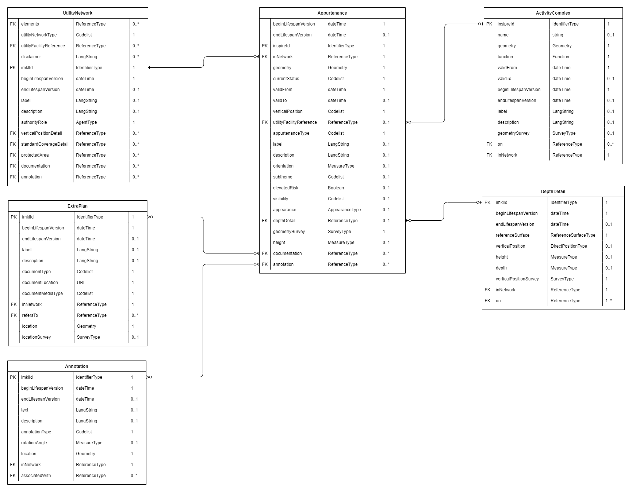

## Connection

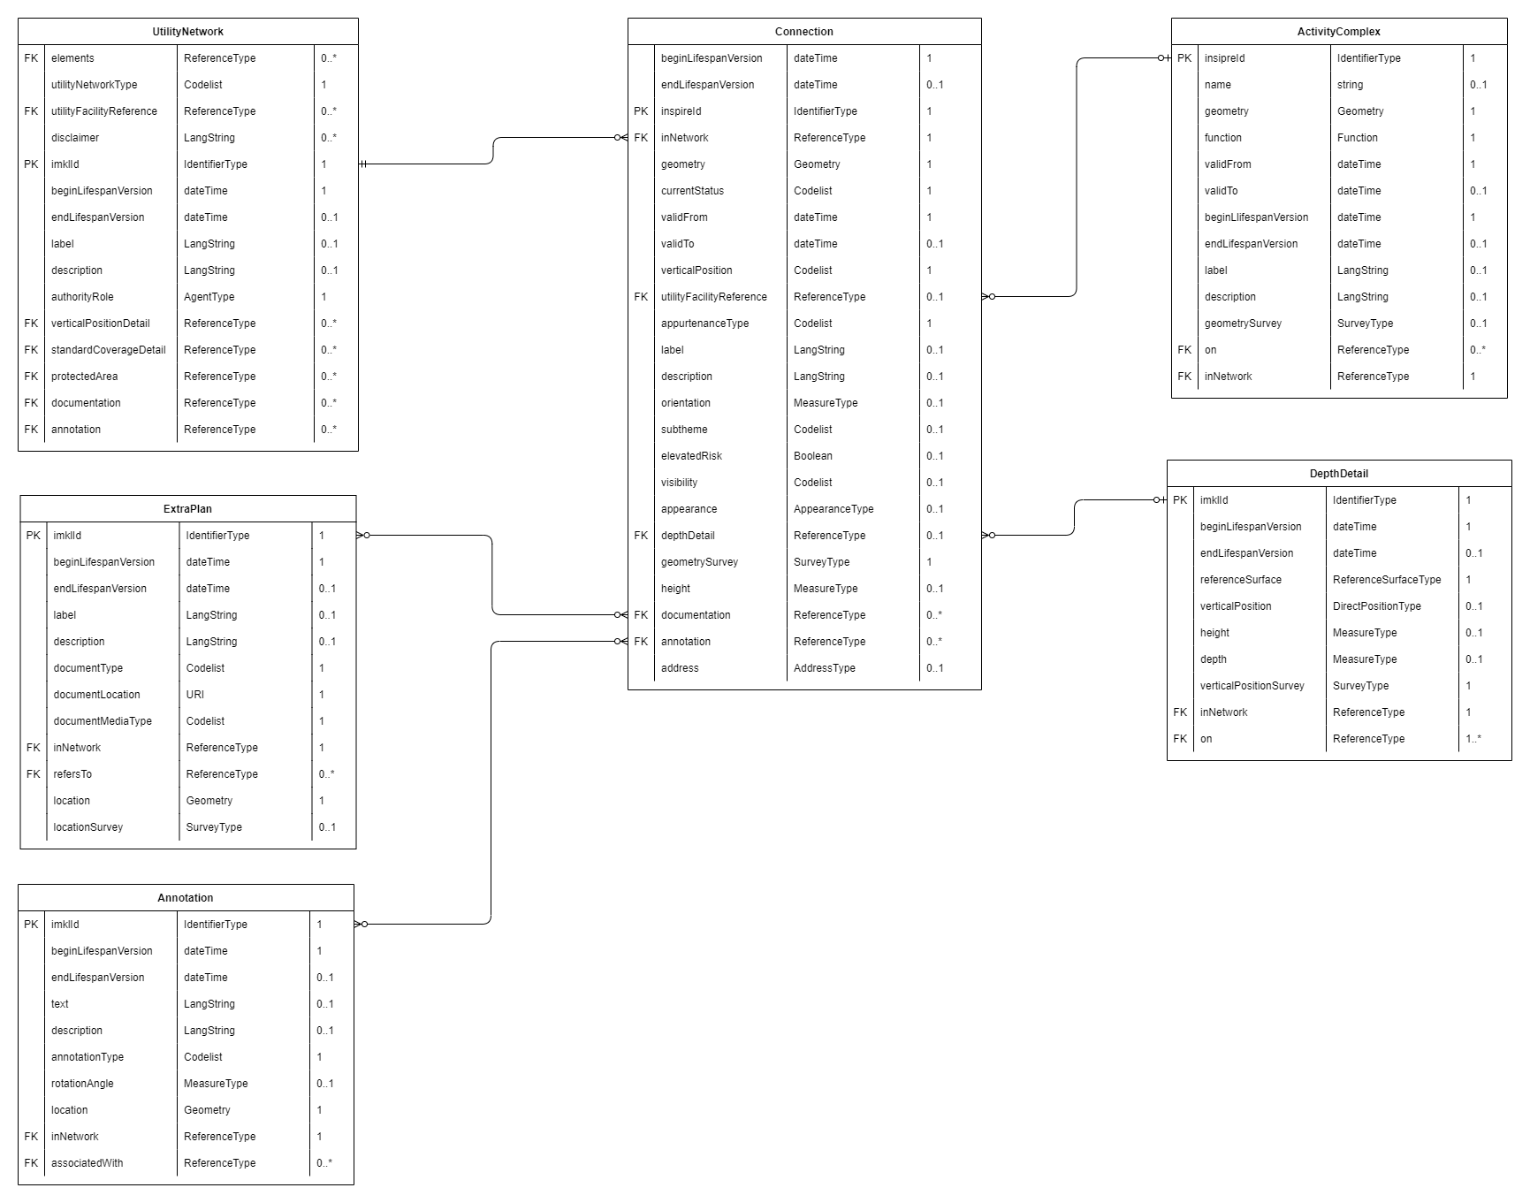

## Tower

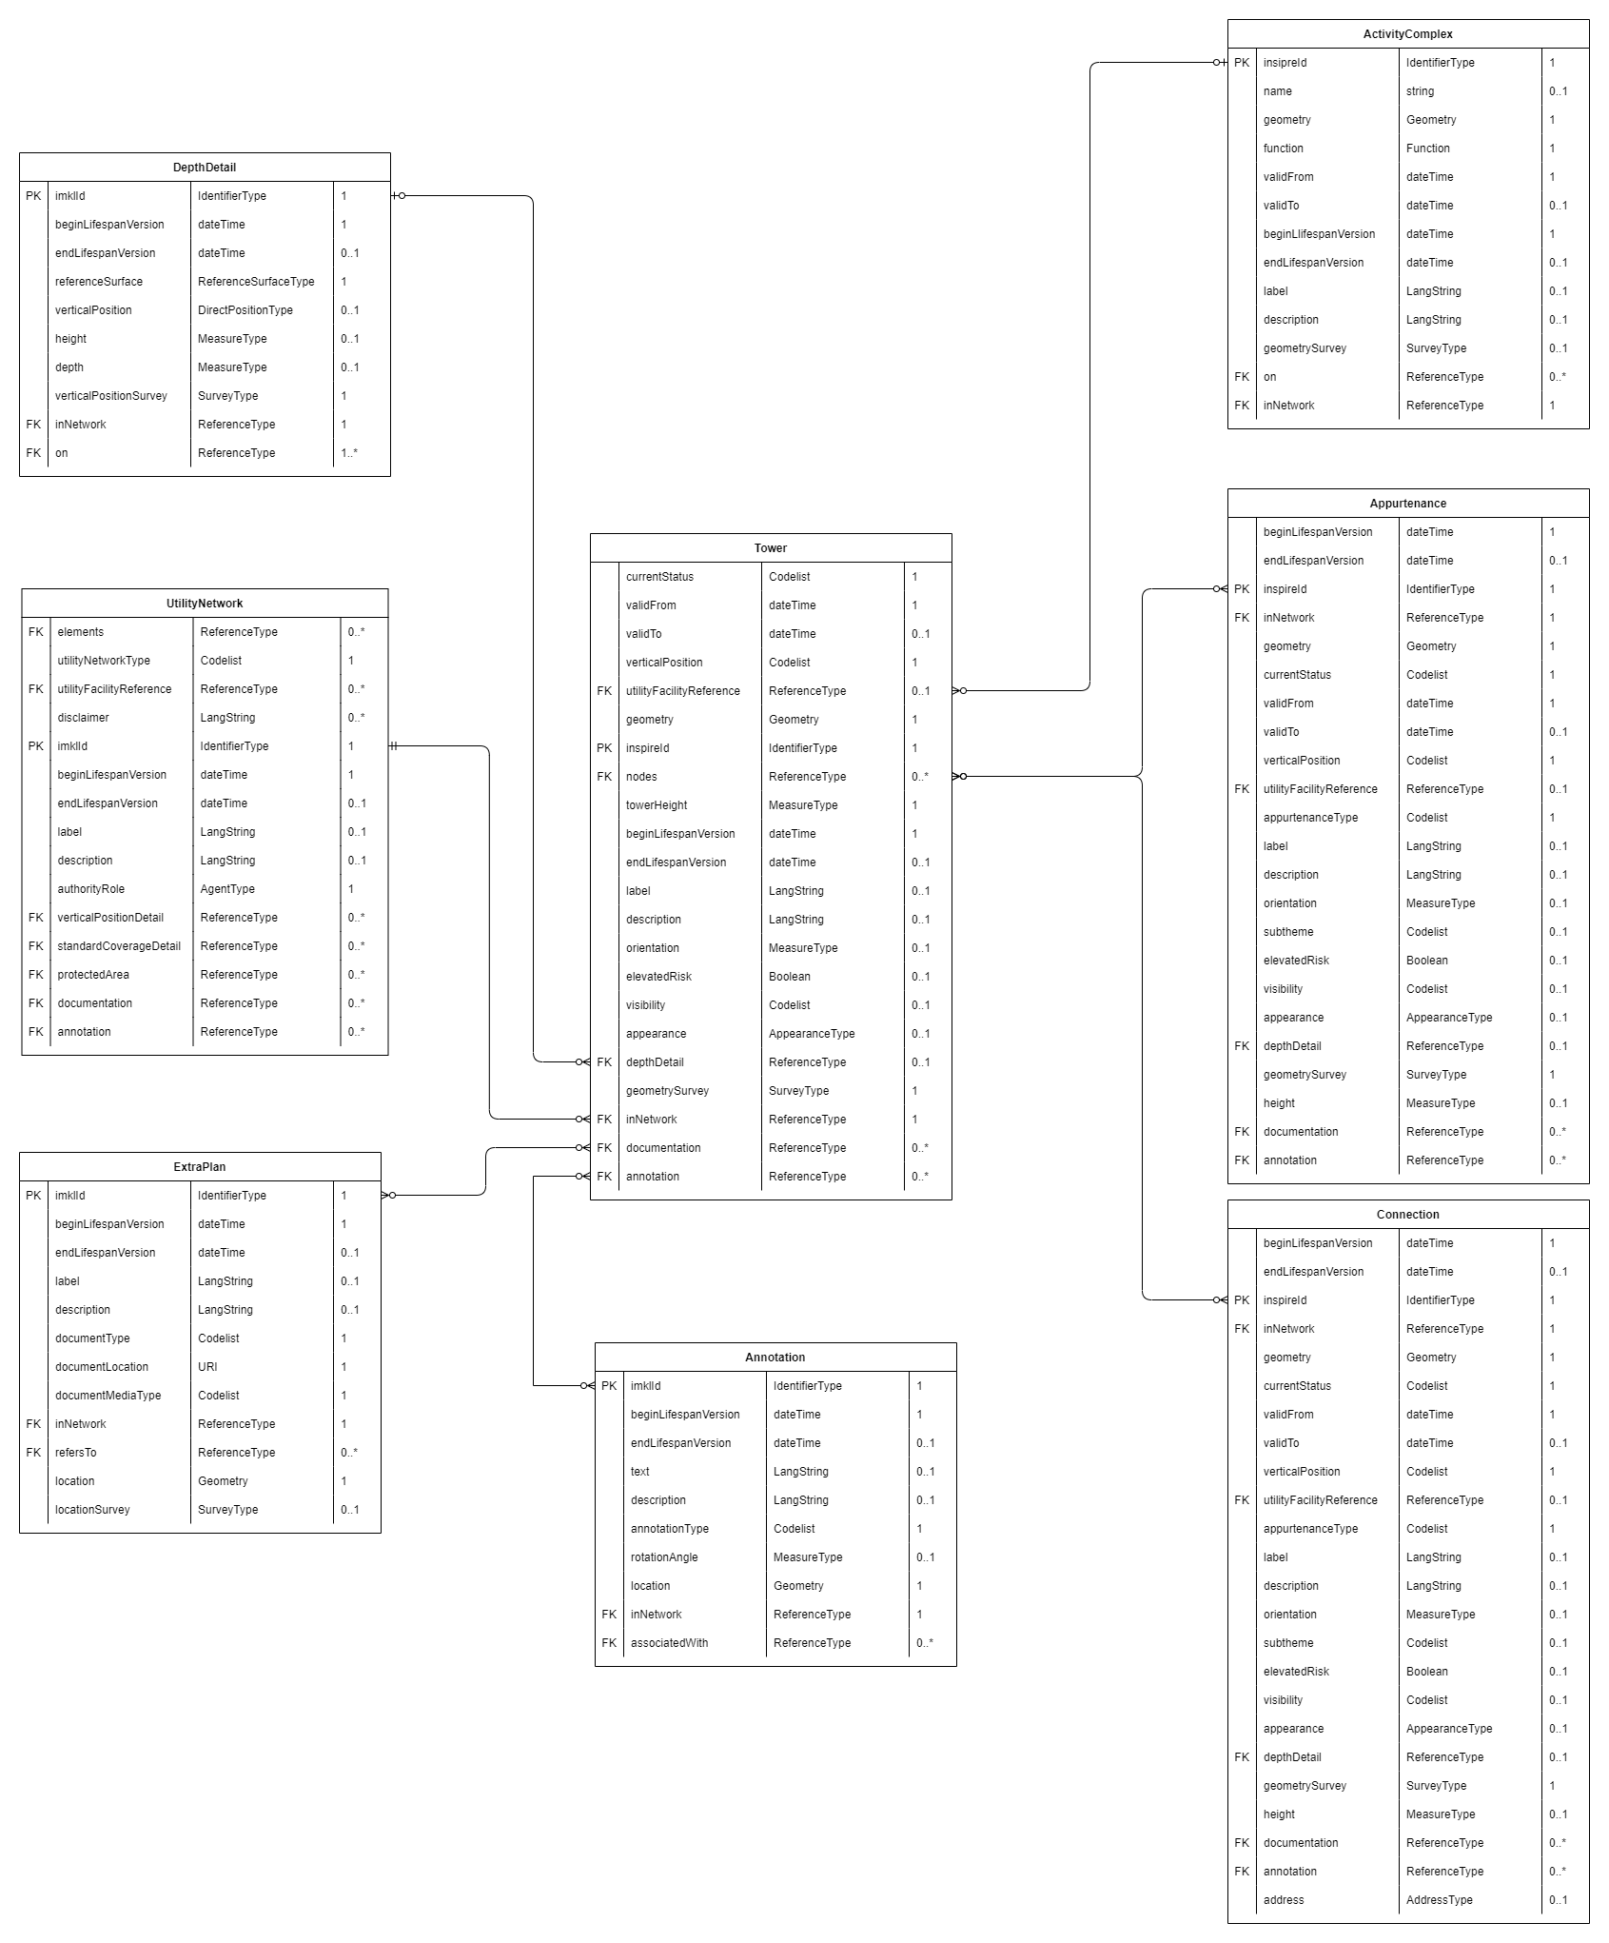

## Pole

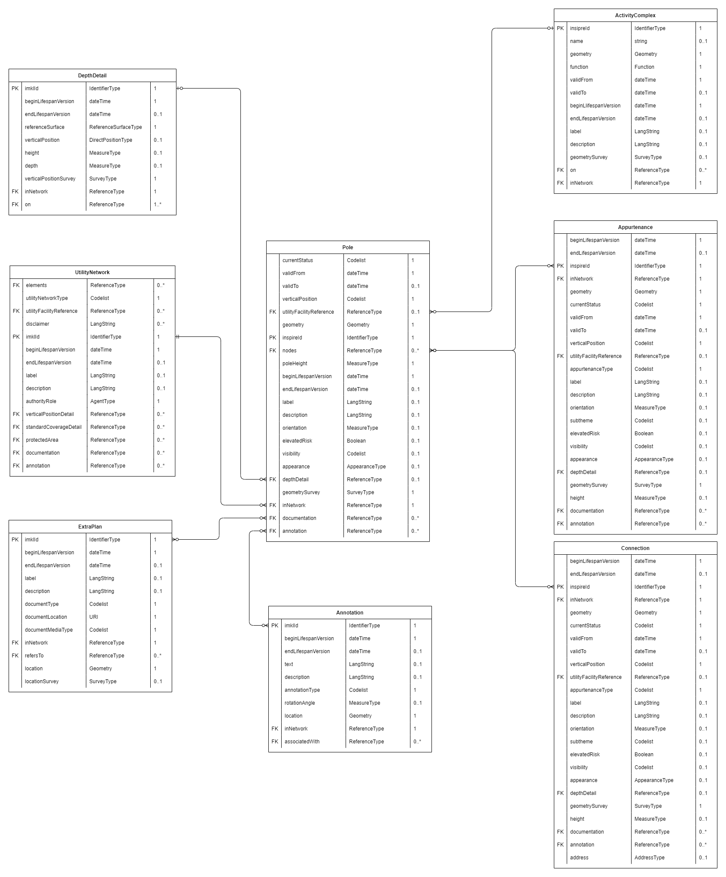

## Manhole

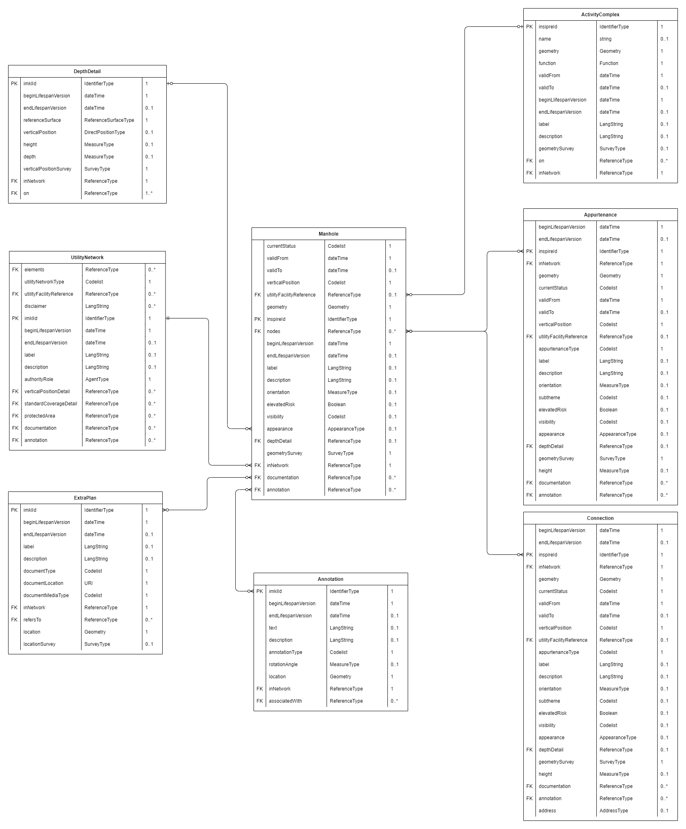

## Cabinet

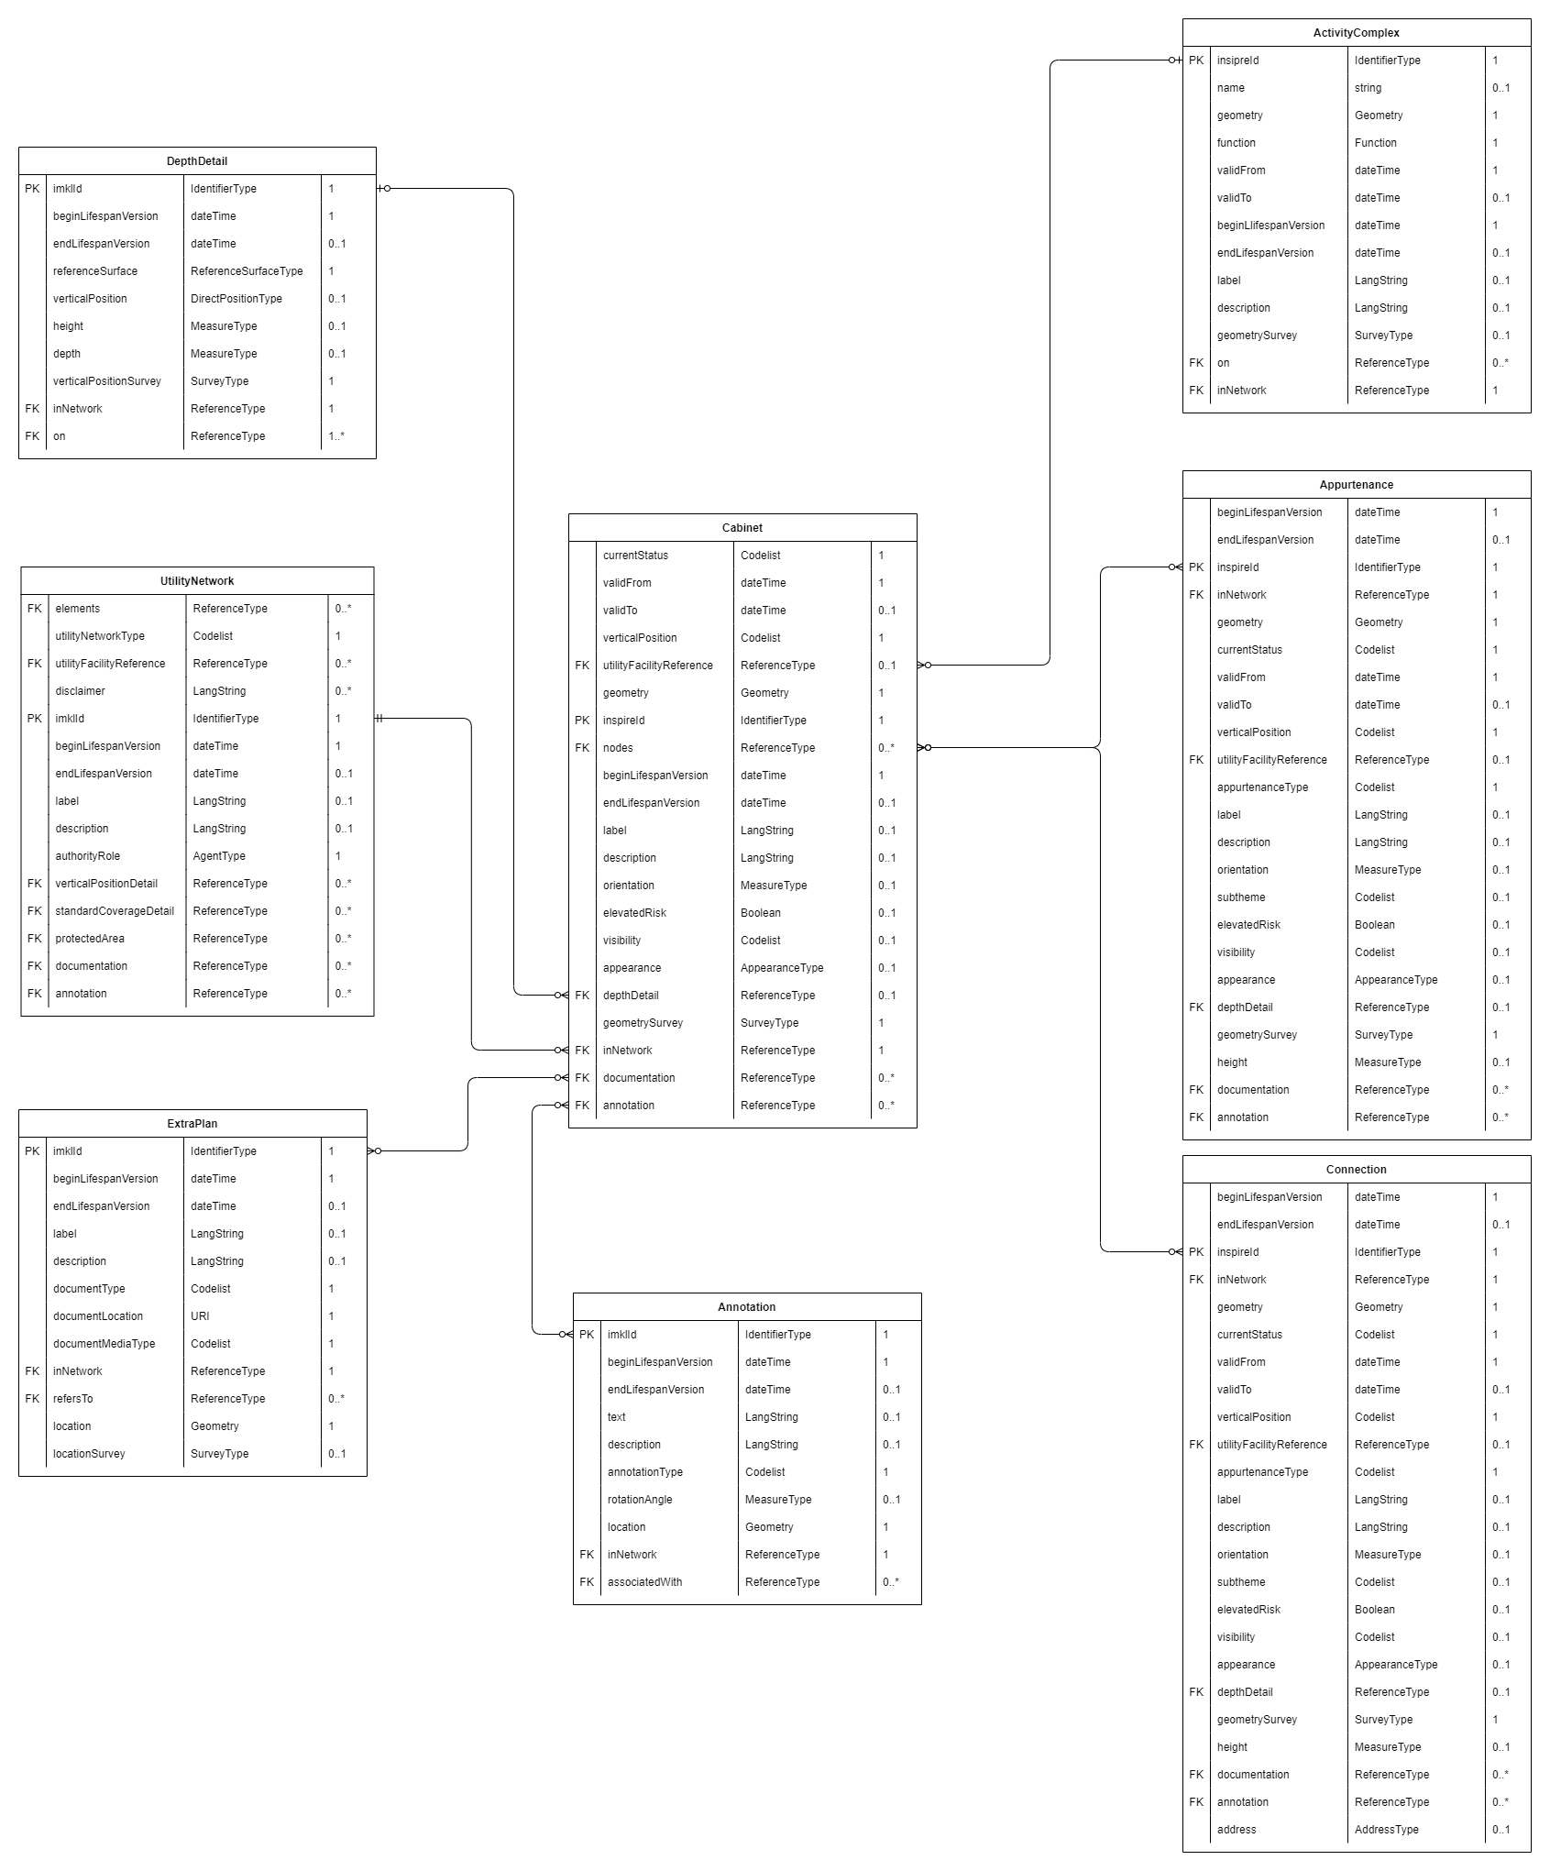

## ElectricityCable

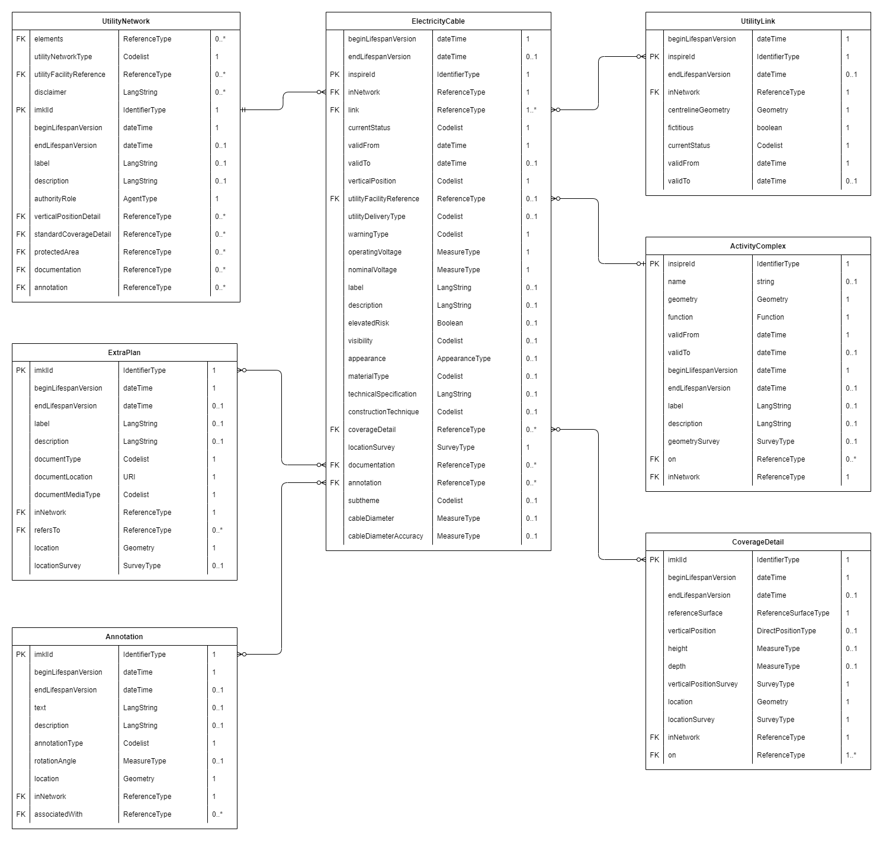

## TelecommunicationsCable

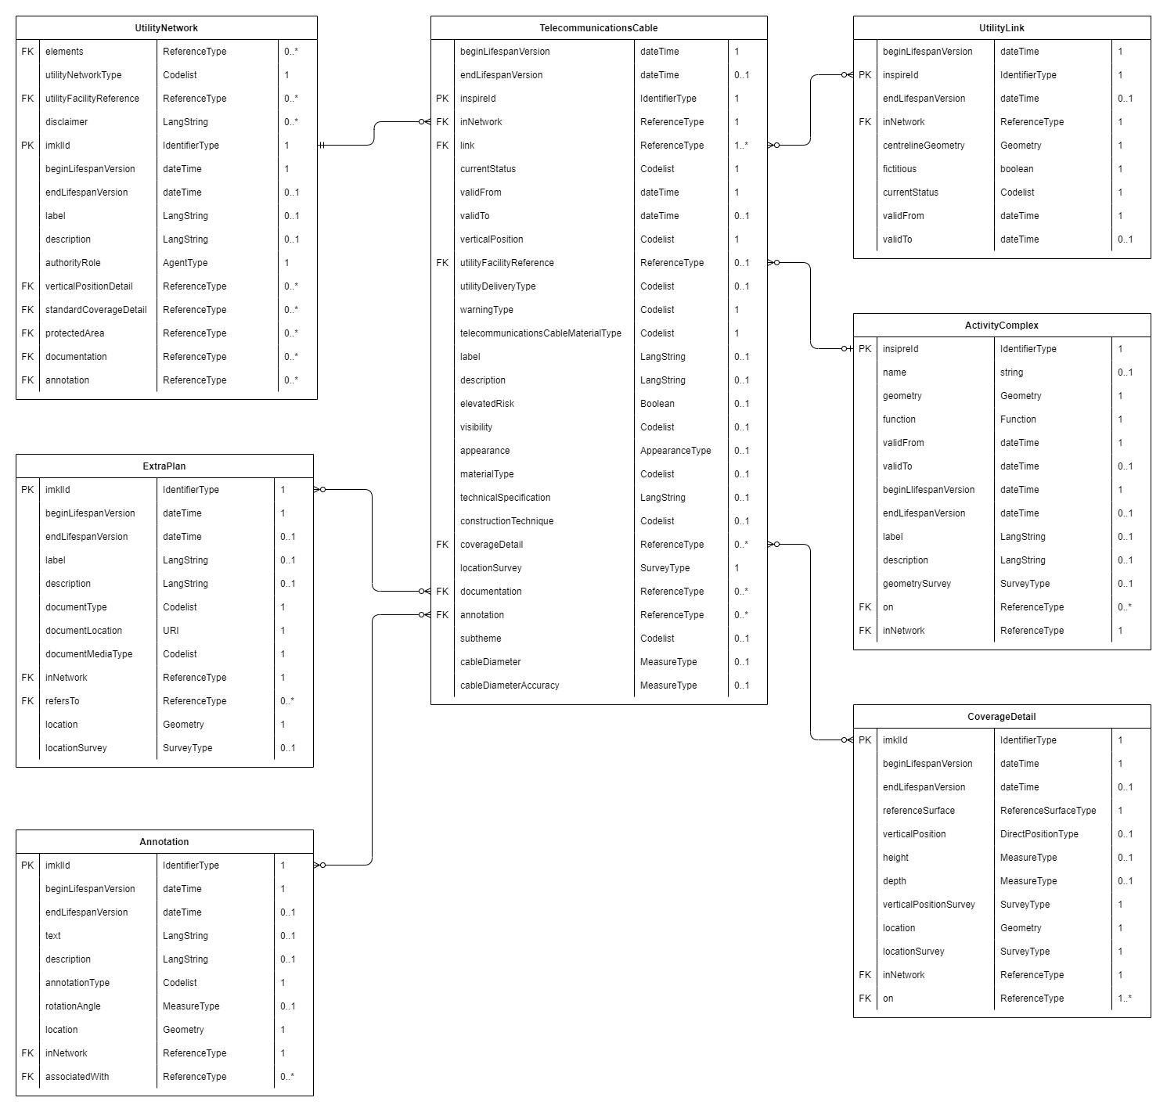

## Pipe

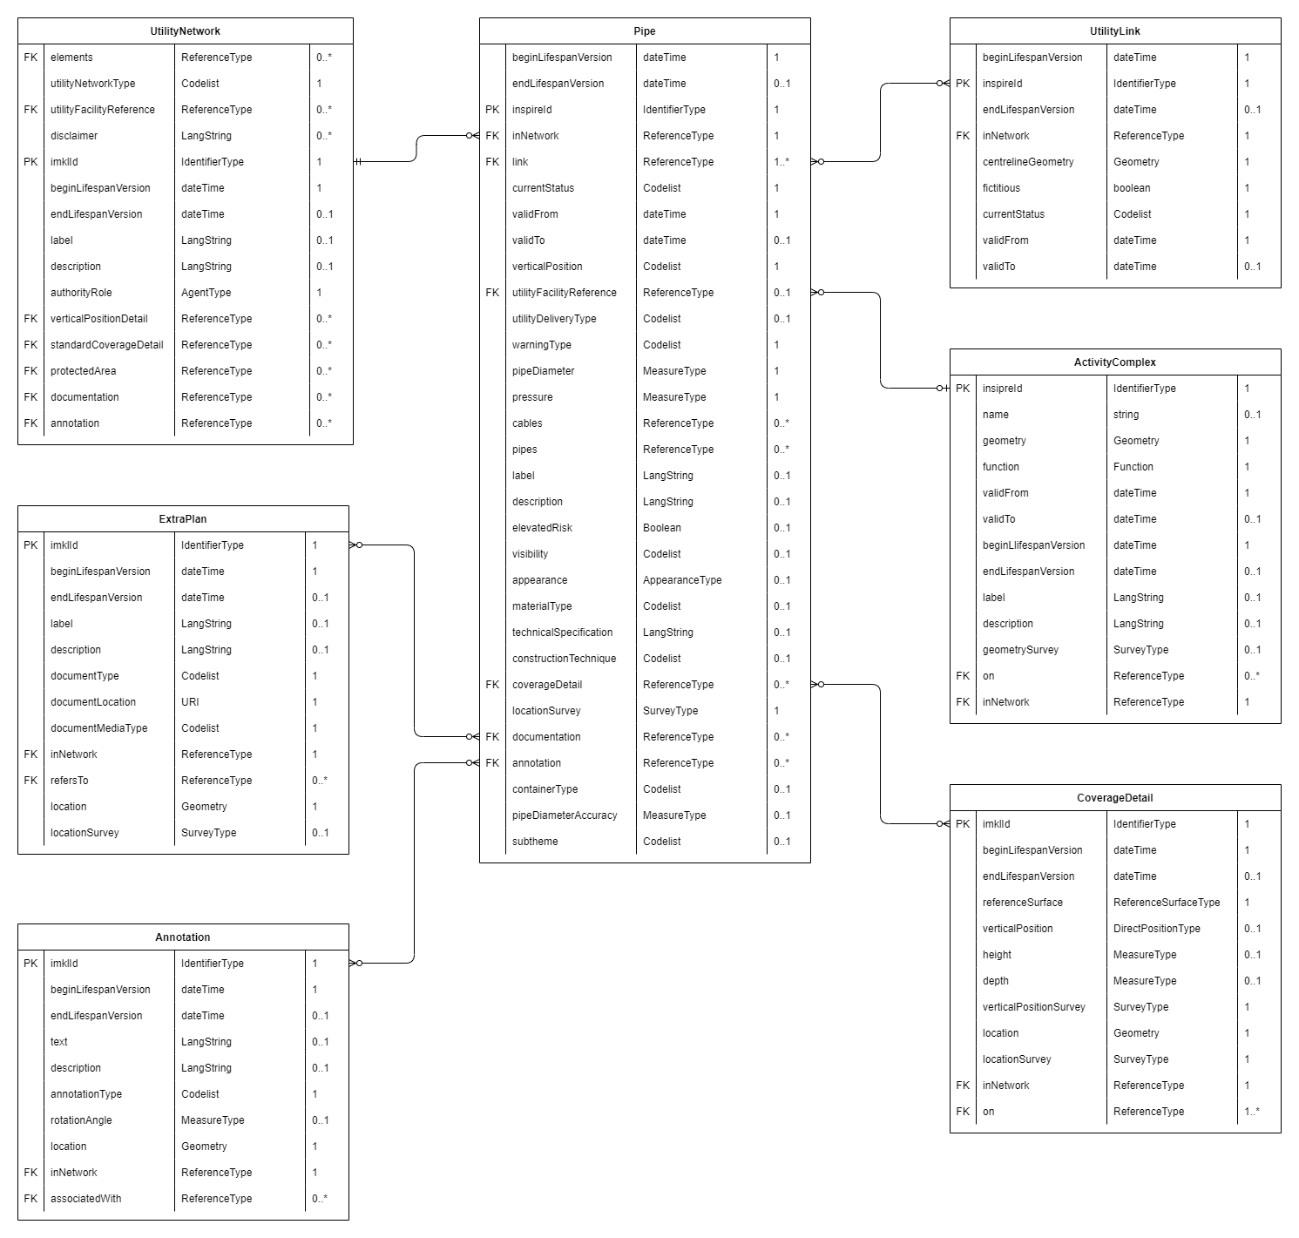

## OilGasChemicalsPipe

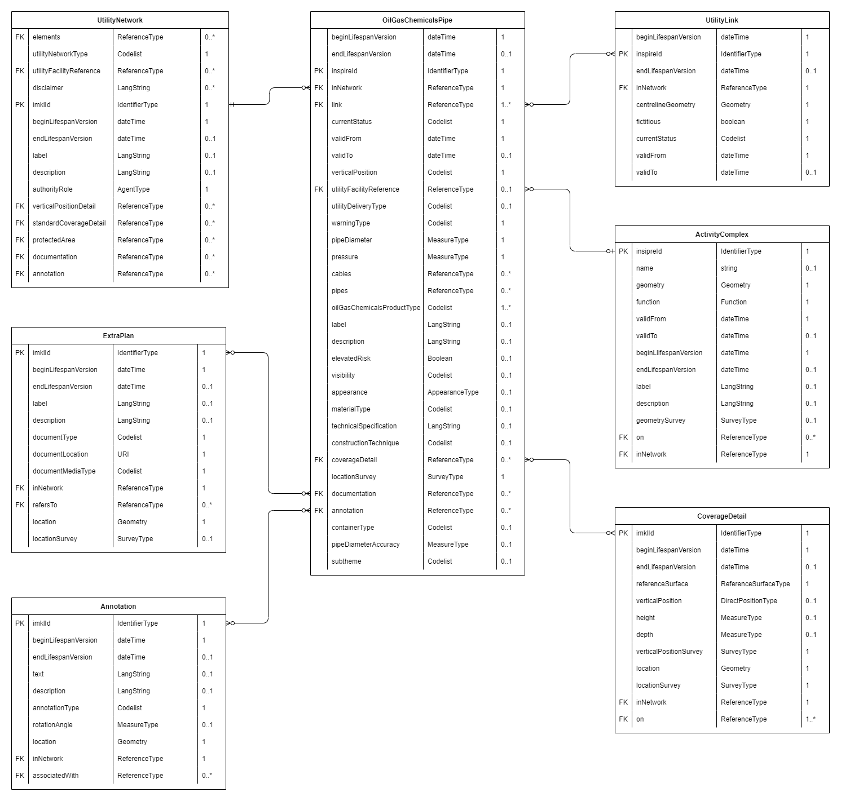

## SewerPipe

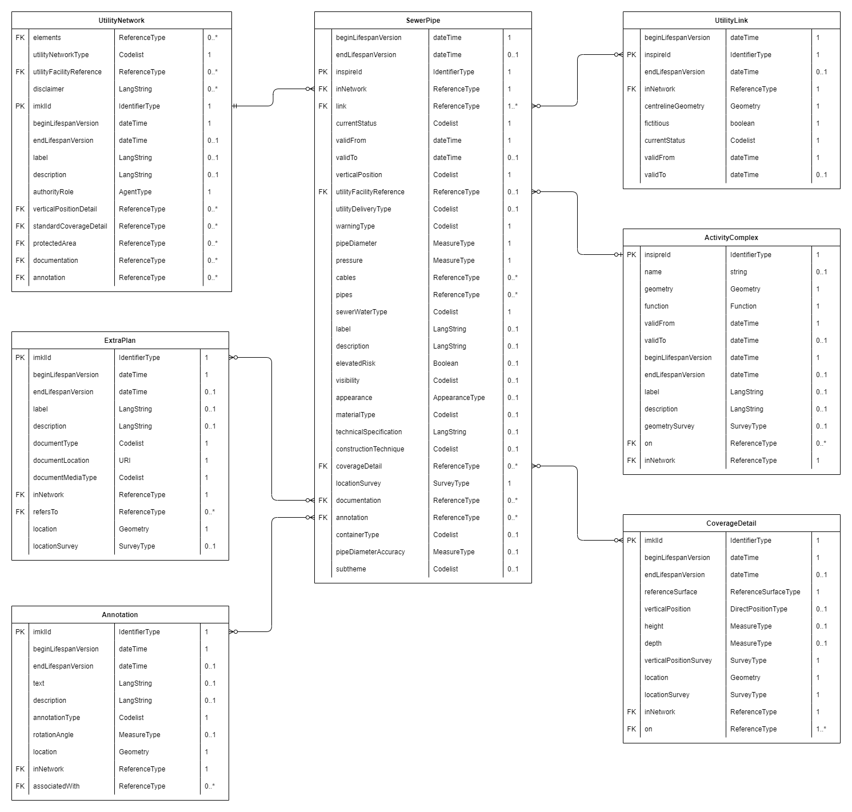

## WaterPipe

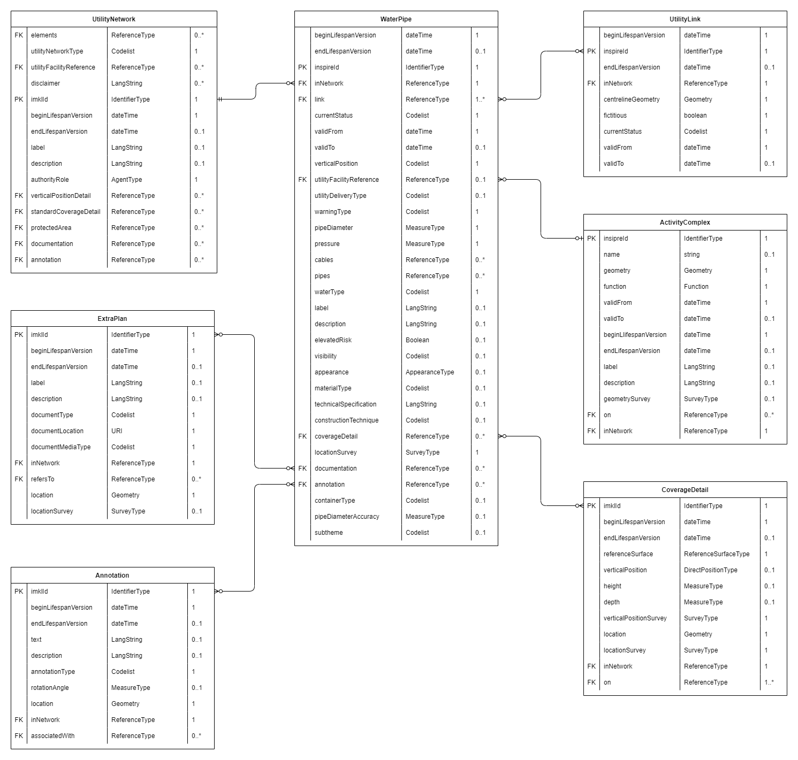

## ThermalPipe

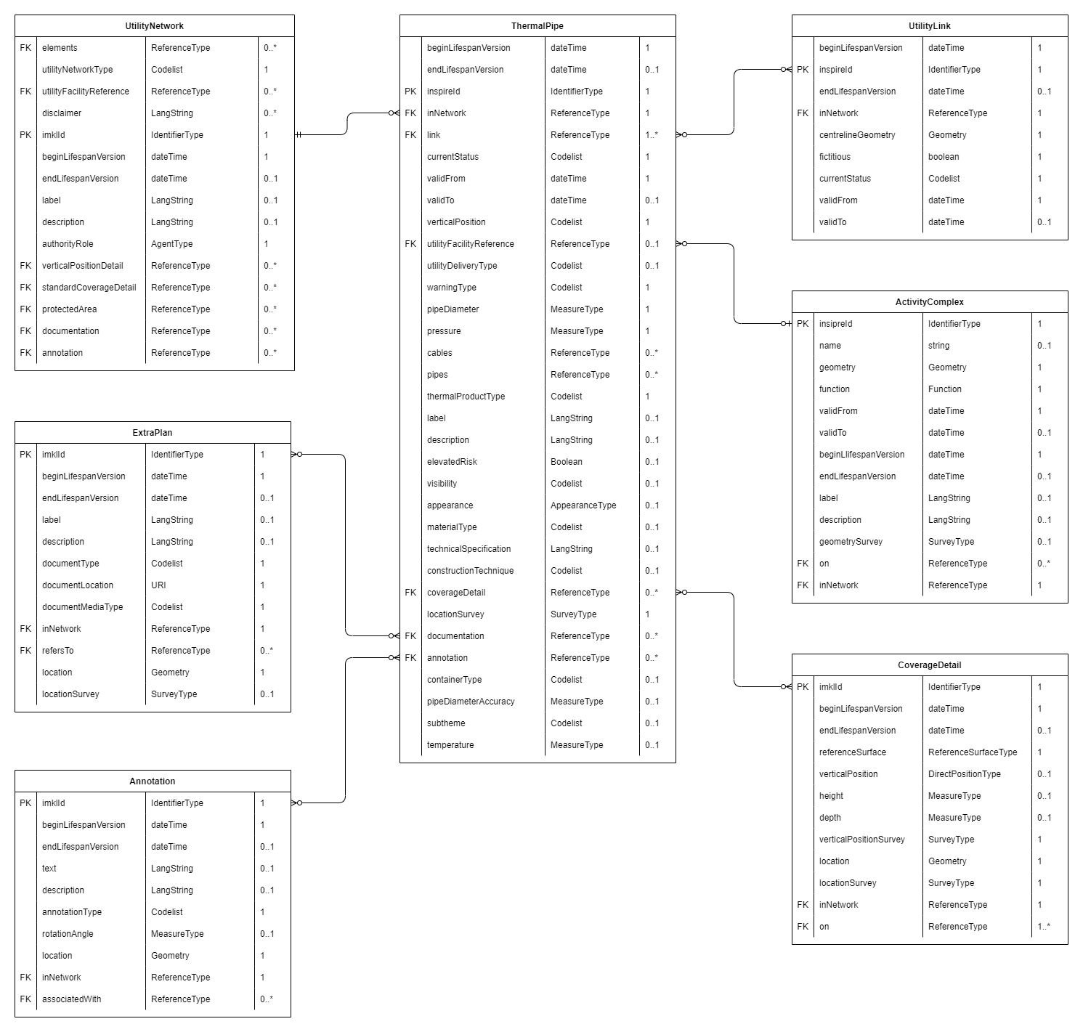

## Duct

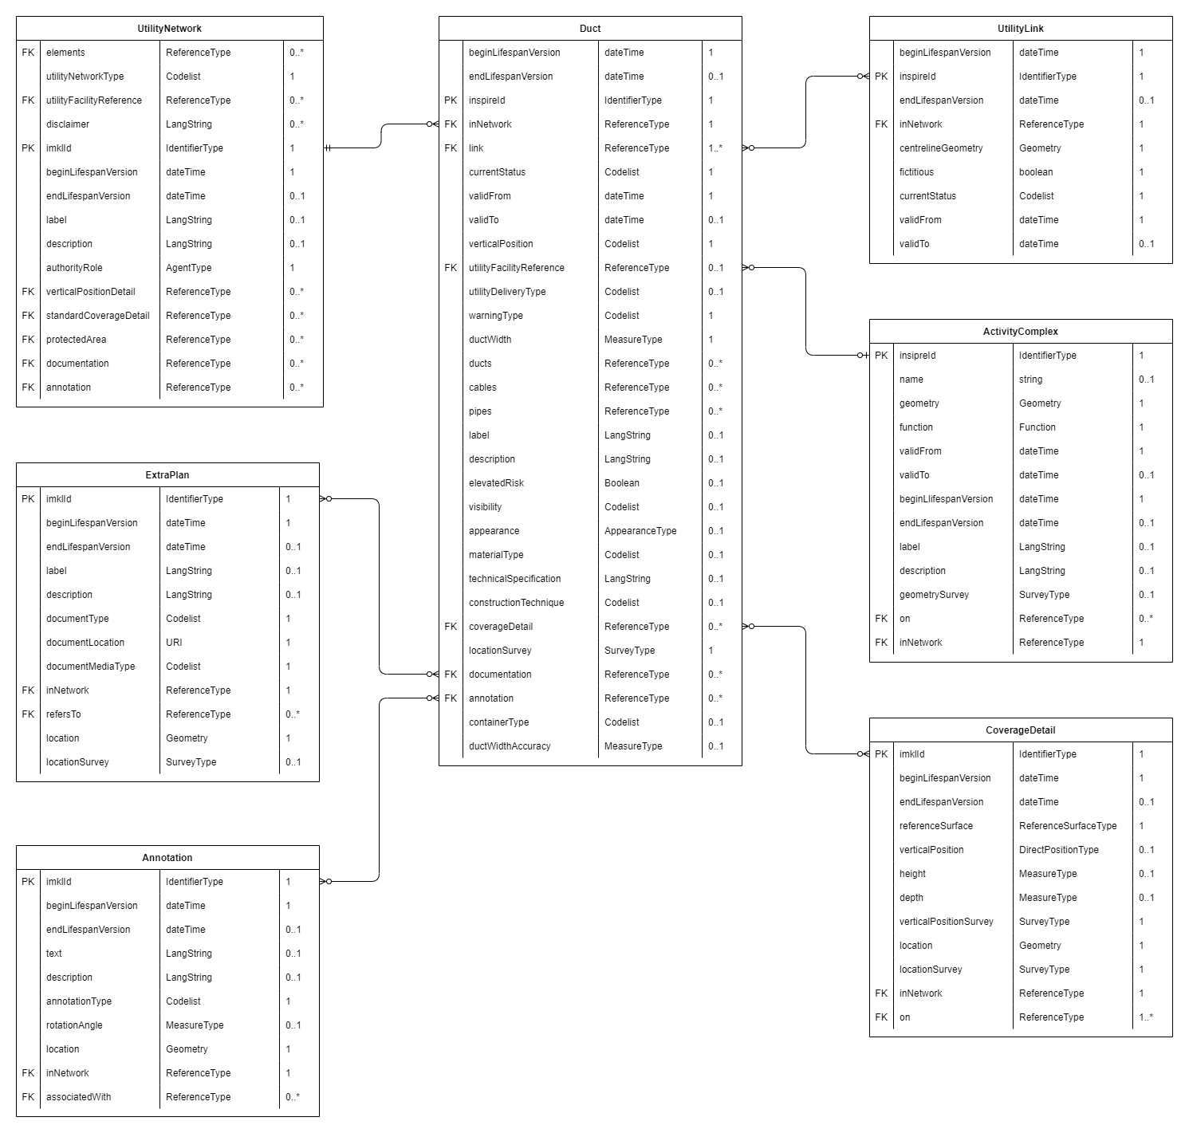

## Document, ExtraPlan and Annotation

## TopographicalElement

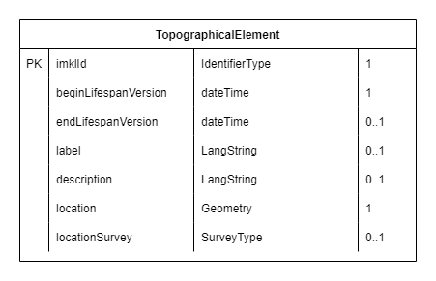

## Types

